King County Health and Human Services Transformation
The Familiar Faces Initiative
Background Information
The Familiar Faces initiative is systems mapping, design, and improvement work centered on creating a system of integrated care for complex health populations that can eventually benefit any user of publicly-funded health services. Familiar Faces are a sentinel population defined as individuals who are frequent utilizers of the King County jail (defined as having been booked four or more times in a twelve-month period) and who also have a mental health and/or substance use condition.
Background
In 2013, King County, in partnership with community stakeholders, developed a plan for an accountable, integrated system of health, human services, and community-based prevention – referred to as the King County Health and Human Services Transformation Plan. The Plan has the goal that by 2020:
The people of King County will experience significant gains in health and well-being because our community worked collectively to make the shift from a costly, crisis-oriented response to health and a social problem, to one that focuses on prevention, embraces recovery, and eliminates disparities.
To catalyze improvement in the system’s performance for everyone, the plan called for an initial focus on areas where improved performance is most critical – for the individuals and communities experiencing the poorest outcomes. The plan also had to align with and be fundamentally committed to the larger King County goal of achieving equity and social justice for county residents.
Following preliminary scoping conversations with several internal and community stakeholders during 2014, one of the initial populations of focus that emerged was individuals with a mental health and/or substance use disorder who are high utilizers of the local criminal justice system – specifically, the King County Jail- the so-called “Familiar Faces.” Many of these individuals experience complex chronic health conditions including: histories of trauma, substance use disorders, mental health and chronic homelessness. These individuals experience instability in many aspects of their lives and are familiar to the various service and provider crisis systems.
The Familiar Faces population was selected as an initial focus with the theory that if system improvements could be made that resulted in better health and social outcomes for these individuals, then the lessons learned would have much broader implications in how our region moves forward with the larger opportunities emerging as a result of the Affordable Care Act.
Working in a New Way
The implementation of the Affordable Care Act has brought new opportunities for the community to work together to achieve the Triple Aim of better health, better care, and lower costs for this initial focus population. These changes include expanded Medicaid coverage, the statewide integration of the mental health, substance use disorder, and physical health systems, and the emerging Accountable Communities of Health and system delivery reform efforts in Washington state.
While there is no shortage of programs in the region that are designed to address the needs of the Familiar Faces – many of which produce excellent results as stand-alone programs – overall fragmentation, uncoordinated care, poor outcomes and growing costs persist for the health, social services, and criminal justice systems, and for our community overall. In short, despite the number of these programs the overall health and social outcomes for the Familiar Faces has not improved.
A new approach was necessary to achieve the vision called for in the King County Health and Human Services Transformation Plan and to improve health and social outcomes for the Familiar Faces population. Past efforts had generally been programmatically focused and failed to affect broad cross-sector policy changes. Two key elements are guiding this new effort and are transforming how we do business:
- Working across silos and sectors to partner in a better way,
- Putting the people and communities at the center of decisions about funding, policy and programs.
A True Cross-sector Approach: Community Driven & Collective Impact*
Partners from across different sectors are using a Collective Impact approach, which commits the group to a common agenda for solving a specific social problem. The Familiar Faces population is engaging in services across a number of different silos, funded by different sources, consisting of different programs. This work is testing whether lasting improvements for Familiar Faces can be achieved by bringing different sectors together to focus on a set of shared outcomes.
*Please see the last page of this document for a list of organizations who participated in the Familiar Faces design work.
People and Communities First
A second aspect of the Transformation Plan is the importance of putting people and communities at the center of identifying and solving problems. This differs from past efforts to improve health and human services, where the focus was on filling gaps rather than improving client outcomes. This past approach has resulted in a patchwork of services that have been deemed “program-centric” rather than “people-centric,” and has ultimately failed to produce improved outcomes for Familiar Faces.

Cross-Sector Design Team Convened
Following a meeting with senior leaders (called Management Guidance Team) from organizations representing housing providers, substance use providers, mental health providers, community health centers, Medicaid Managed Care Organizations, Washington State’s Health Care Authority and Department of Social and Health Services, King County’s Public Health department and Department of Community and Human Services, the City of Seattle, criminal justice organizations including courts, police, and the King County Department of Adult and Juvenile Detention and others, a Design Team of individuals representing these organizations was convened. Their charge was to work collectively on designing a Future State Vision for the Familiar Faces in our region to achieve the following outcomes:
- Improved Health
- Improved Housing Stability
- Reduced Emergency Department Usage
- Reduced Criminal Justice Involvement
- Improved Client Satisfaction
Using Lean tools, the Design Team spent approximately five months between October 2014 and February 2015 developing a Current State Map of the various systems serving the Familiar Faces population. This was done primarily in three ways. First, the team gained a firsthand understanding of how the Familiar Faces were enrolled, treated, and referred across the various systems by participating in “process walks” of all related work. Next, some of the providers simply asked the Familiar Faces they work with, “What do you need to achieve more stability?” The third and final strategy was to gather data from the systems serving the Familiar Faces population to gain a better understanding of their lives, what services they use and how we might design a better system where there is improved health and stability.
Data Breakthrough & Summary
Data matching was a significant process victory for the Familiar Faces initiative, as three distinct King County Departments, City of Seattle, and other housing and social service partners, broke down traditional data silos to share information. This exercise in gathering data gave the Design Team a much more comprehensive picture of the Familiar Faces population and showed the following:
- The Familiar Faces are disproportionally people of color compared with King County as a whole and overall jail population
- In 2013, there were 1,273 Familiar Faces. In 2014, there were 1,252 Familiar Faces.
- 94% of all people with 4 or more jail bookings have a behavioral health indicator.
- 93% had at least one acute medical condition (average 8.7 conditions); 51% had at least one chronic health condition (average 1.8 conditions)
- More than 50% were homeless
- The Most Serious Offenses (MSO) were:
  - Non-compliance (41%) – Failure to appear for court, supervision violations, etc.
  - Property crime (18%)
  - Drugs (13%)
- Only 8.5% of 2014 Familiar Faces (FFs) had opted-in to any of the three adult specialty courts during 2014 (Drug Diversion Court or either the King County or City of Seattle Mental Health Courts)
- About 50% of the 2013/14 FF’s (aged 24 and under) have had contact with the juvenile justice system
- Despite having at least four bookings in the King County Jail, over 40% of FF also had municipal jail episodes during the same year (there are 5 municipal misdemeanor jails in King County in addition to the King County Jail’s two sites in Seattle and Kent)
Current State Mapping Event
In early March 2015, the Design Team came together in a two day event and put all of this information together to complete the Current State Map (see Figure 1 below) for the Familiar Faces population. There were a few key themes that emerged from the day including:
- It’s not really a system, it’s more a collection of uncoordinated services
- The current “system” is program-centric, not people-centric
- Funding stream requirements drive the current system
- There are philosophical difference across the value stream
- Need to stop “brick and mortar thinking”

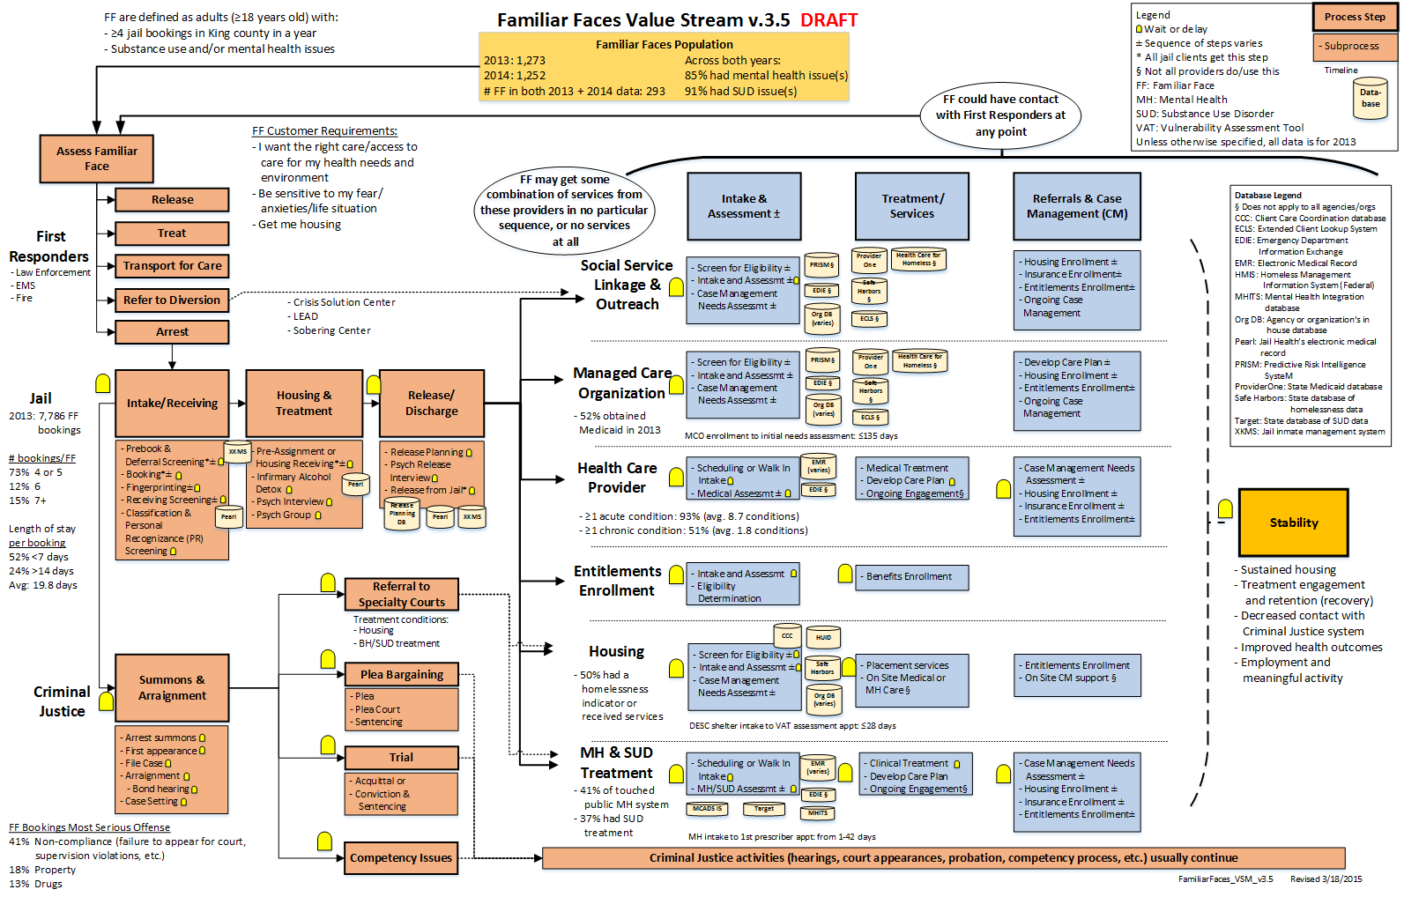
Figure 1: Familiar Faces Current State Map: There are pockets of excellence, but no system of excellence
A Path Forward
After the Current State Mapping exercise, the Design Team reconvened to rethink what the system needed to look like in a Future State Vision if the needs of the Familiar Faces were at the center of how our community responded. The map that emerged looked quite different from the Current State Map (see Figure 2 below).
The Future State Vision puts the Familiar Face at the center of a care team that includes the flexibility to accommodate the level of care and specific needs the individual has at the time regardless of payer. The care team is one that uses a trauma informed approach, motivational interviewing methods, is based in harm reduction and utilizes evidence-based practices, where applicable. Some of the general areas for improvement in order that were identified to make progress towards this vision include:
- The need for a single, standard and consistent care plan
- A cross-sector integrated data system that would have clinical look-up and data extract capacity
- An agreed upon portfolio of human services based in a Familiar Faces driven approach that uses trauma-informed motivational interviewing approaches aligned with harm reduction
- Development of outreach and quick response processes
- Unconditional and flexible funds regardless of payer
- Development of standard work for jails and emergency departments
- Drop-in campuses connected virtually with telehealth that may also serve as diversion points for first responders
- Development of standards and standard work for warrant prevention and quashing
- Policy Improvements for law enforcement
- Definition and development of a community support team
- Benefits reform
- A system for on-demand access to housing
- Definition and development of care management teams
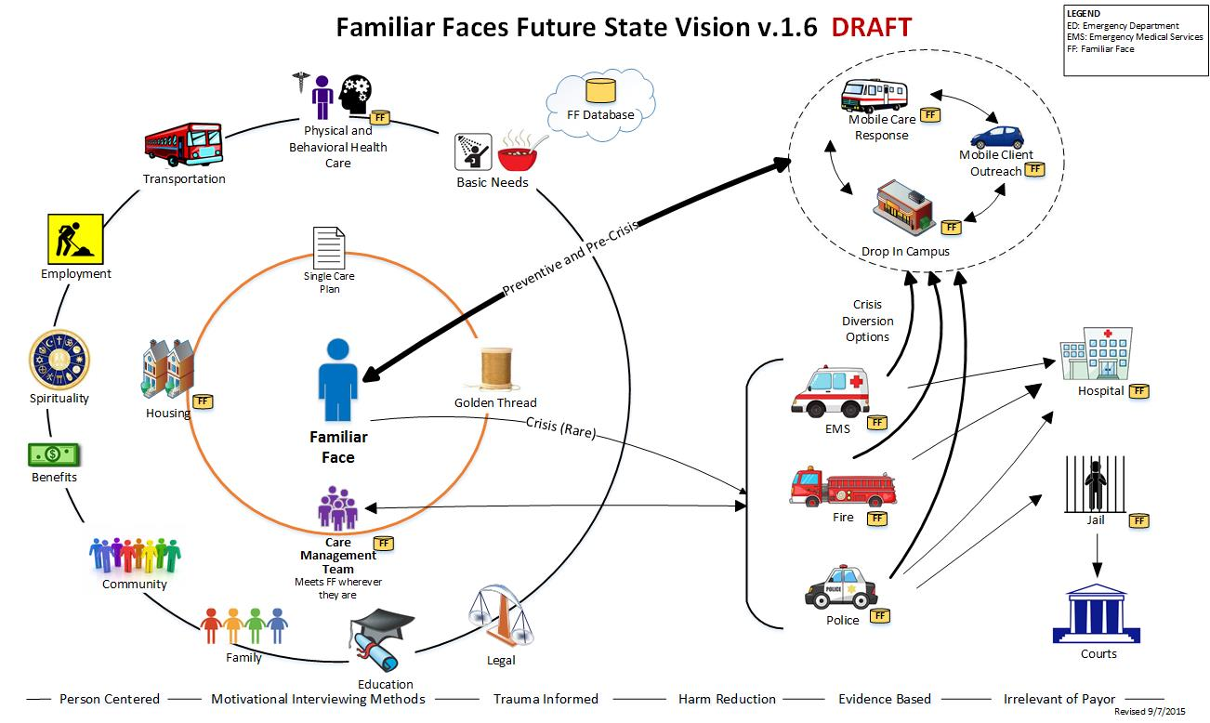
Figure 2: Person-centered, standard approaches across systems that are evidence-based, regardless of payer
Familiar Faces Governance Structure
In early 2016, a subset of the original Familiar Faces Management Guidance Team, along with Familiar Faces Advisors formally aligned to form the Familiar Faces Steering Committee, which will help provide ongoing guidance and support as improvement strategies are developed, deployed, tested, and eventually spread across the region. The Steering Committee will be closely aligned with Physical and Behavioral Integration Design Committee, the Accountable Community of Health and developments related to Washington’s recent application for an 1115 Medicaid Waiver. The Steering Committee is a formal collaborative of community partners that meets regularly to help guide the efforts, provide leadership support, and assist in removing barriers in the many efforts towards actualizing the Future State Vision for Familiar Faces. As programs and strategies are implemented for Familiar Faces, this will inform an integrated health and human services system that not only prevents individuals from becoming Familiar Faces, but illustrates a system that benefits all people in King County who have behavioral health issues.
What’s next?
In early 2016, ‘go-first’ strategies were proposed and approved by the Steering Committee for implementation towards the future-state. Please see the companion handout about Familiar Faces Implementation Strategies.

Familiar Faces Advisors is a four-person advisory group of individuals who have former experience as high utilizers of the jail to provide ongoing consultation and participation in the Familiar Faces design work.

