King County Comprehensive Plan 2012 (2013 Update)

Adopted December 3, 2012
Update adopted November 4, 2013

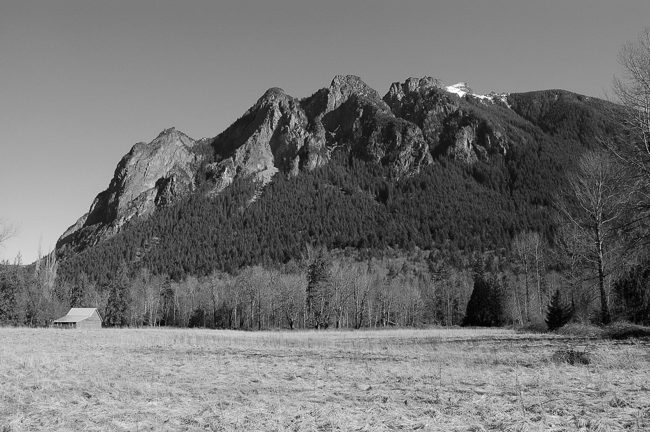

King County Department of Permitting and Environmental Review
35030 SE Douglas St., Suite 210
Snoqualmie, WA 98065-9266

