Civic Space Standards

1. Introduction
This article provides standards to regulate the design and function of civic spaces. Each civic space has a different purpose and serves different users. The design of civic spaces provided should reflect the adjacent buildings, natural environment, and the needs of intended users.

A. General Standards (All Transects)
- Civic spaces should be accessible to a variety of users by providing streets, bikeways, walkways, and transit stops within close proximity. Bikeways and walkways within civic spaces should connect to the adjacent bikeway and walkway networks.
- The edges of public spaces (excluding edges of regional parks that abut T1 zones) shall be open in nature and be defined by streets and building frontages, not backs of buildings and fences/walls.
- Civic spaces (except for regional parks that are closed before sunset and have controlled access points) shall be illuminated to increase safety for evening and nighttime users.

2. Regional Park
Regional parks are large natural preserves that are available for generally unstructured recreation. These parks may be designed independent of adjacent building frontages. These parks are generally located in natural and rural areas and near the edges of communities. They are sized to serve a range of users throughout the community. These parks generally emphasize natural uses (i.e. hiking trails and ponds for boating and fishing) and gathering areas (i.e. family picnic areas).
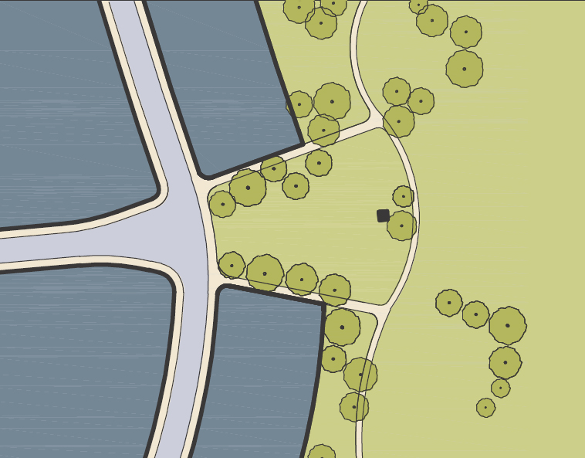

A. Location
Regional parks are allowed in the T1, T2A, T2B, and T3 zones. Regional parks are generally defined by natural boundaries (i.e. streams and hills) and/or constructed boundaries (i.e. property lines and streets). These parks may be linear in design and follow natural corridors (i.e. streams) and constructed corridors (i.e. abandoned railroad corridors).

B. Size
Regional parks shall be a minimum of 20 acres. Smaller parks may be provided along linear corridors.

C. Amenities and Facilities
The following facilities and uses should be provided in regional parks.
- Restrooms and Drinking Fountains
- Food Concessions
- Ticket Sales and Equipment Rental (bikes, kayaks, paddle boats, etc.)
- Picnic Areas
- Paths and Trails, including paths for Pedestrians, Bicyclists, and Equestrians
- Marinas for Lakes and Ponds (if provided)
- Playgrounds
- Grass fields for unstructured recreation
- Benches
- Trash and recycle bins
- Exercise stations (located along paths and trails)
- Dog Parks
- Pedestrian-Scaled Lighting with fully shielded cutoff devices (located along paths and trails)
- Signage and Kiosks
- Public Art and Interpretive Features
The following facilities and uses may be allowed with a conditional use permit:
- Community Centers and Clubhouses
- Amphitheaters and Performance Stages
- Stadiums (which may include taller and brighter lighting)
- Campgrounds
- Sports fields and courts for structured recreation.

D. Landscaping
Landscaping shall be provided in an organic (naturalistic) pattern and may include meadows, woodlands, bodies of water, and natural open areas.

E. Parking
Surface parking lots are required for all regional parks. Parking spaced shall be provided at a rate determined by the Director.

3. Neighborhood Park (Green)
Neighborhood parks are medium-to-large open spaces that are available for both unstructured recreation and structured recreation. These parks may be designed independent of adjacent building frontages and may be defined by landscaping and streets where buildings do not define the edges. These parks are generally located within a neighborhood and are sized to serve the specific needs of neighborhood residents and visitors. These parks generally emphasize active uses (i.e. playing fields and sports courts) in more rural and transition areas and passive uses (i.e. community gardens and strolling paths with benches) in more urban areas.
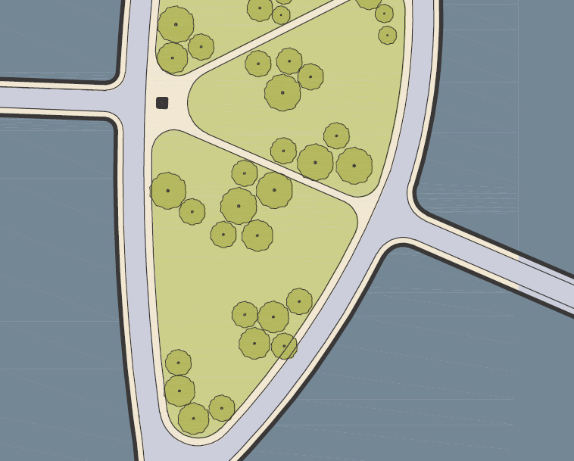

A. Location
Neighborhood parks are allowed in the T2B, T2C, T3, T4, and T5 zones. At least 1 edge of the neighborhood park shall be defined by a street. Private properties that bound a neighborhood park should provide front facades along the edge of the park.

B. Size
Neighborhood parks shall be a minimum of 1.5 acres and a maximum of 8 acres.

C. Amenities and Facilities
The following facilities and uses should be provided in neighborhood parks.
- Restrooms and Drinking Fountains
- Picnic Areas
- Gazebos
- Paths and Trails for Pedestrians and Bicyclists
- Grass fields for unstructured recreation.
- Playgrounds
- Playing Fields and Sports Courts
- Dog parks
- Exercise stations (located along paths and trails)
- Benches
- Trash and recycle bins
- Pedestrian-Scaled Lighting with fully shielded cutoff devices (located along paths and trails)
- Signage and Kiosks
- Public Art and Interpretive Features
- Community Garden Plots
The following facilities and uses may be allowed with a conditional use permit:
- Community Centers and Clubhouses
- Amphitheaters and Performance Stages
- Food Concessions and Mobile Vendors

D. Landscaping
Landscaping should be provided in a generally organic (naturalistic) pattern with more formal landscaping patterns lining streets and paths. Landscaping should include a variety of tree species and lawn areas. Additionally, shrubs and groundcovers should be provided. Special features—such as rose gardens, community garden plots, labyrinths, bonsai gardens, and small-scale orchards—also may be provided throughout neighborhood parks.

E. Parking
Surface parking is not required for neighborhood parks unless it has facilities for sports tournaments, aquatic centers, and other uses that would draw people from outside the neighborhood. Parking for these types of uses shall be determined by the Director.

4. Square
Squares are small-to-medium open spaces that are available for generally unstructured recreation and civic uses. These civic spaces shall be defined by streets and building frontages. These spaces are sized to serve the specific needs of the adjacent neighborhood and may have a regional draw, especially within commercial areas. These civic spaces generally emphasize passive and civic uses, such as open areas to relax, benches, and performance spaces.
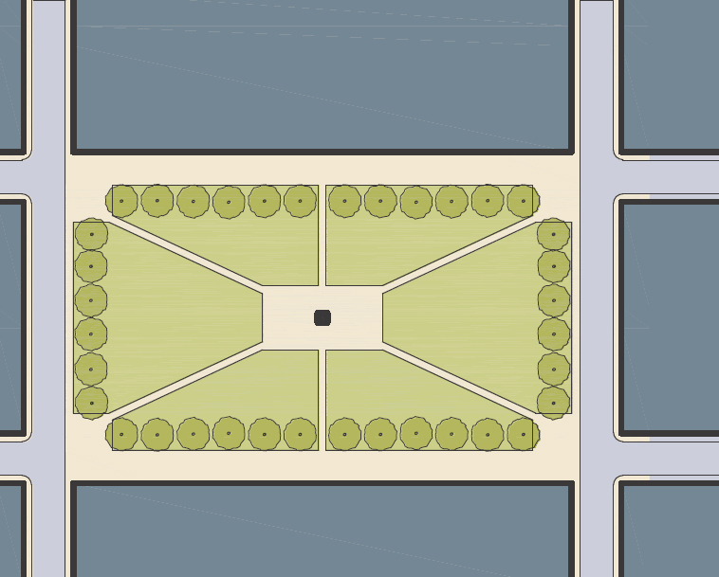

A. Location
Squares are allowed in the T2C, T3, T4, and T5 zones. All edges of squares shall be defined by streets. Up to 2 of these streets (parallel to each other) may be converted into pedestrian-only promenades that generally maintain the width and character of the adjacent streets. These spaces are generally located in the middle of a neighborhood and are adjacent to at least one locally significant street.

B. Size
Squares shall be a minimum of 1 acre and a maximum of 5 acres.

C. Amenities and Facilities
The following facilities and uses should be provided in squares:
- Restrooms and Drinking Fountains
- Seating areas
- Gazebos
- Paths for Pedestrians
- Playgrounds
- Fountains and Water Features
- Benches
- Trash and recycle bins
- Pedestrian-Scaled Lighting with fully shielded cutoff devices (located along paths)
- Signage and Kiosks
- Public Art and Interpretive Features
- Community Garden Plots
- Rose Gardens, Bonsai Gardens, Small-Scale Orchards, and similar features
The following facilities and uses shall be allowed by a conditional use permit:
- Food Concessions, Mobile Vendors, and Micro Retail
- Amphitheaters and Performance Stages
- Small Sports Courts
- Community Centers and Clubhouses
- Dog Parks

D. Landscaping
Landscaping should be provided in formal patterns and line paths, street edges, and open areas. Landscaping should include a variety of tree species and open lawn areas.

E. Parking
There are no parking requirements for squares.

5. Plaza
Plazas are small-to-medium open spaces that are available for civic uses and commercial activities. These civic spaces shall be defined by streets and building frontages. These spaces are sized to serve the specific needs of the adjacent commercial and civic uses and generally have a regional draw. These civic spaces generally emphasize passive and civic uses, such as open areas to relax, benches, and performance spaces. Plazas are similar to squares but are generally designed with more paved surfaces.
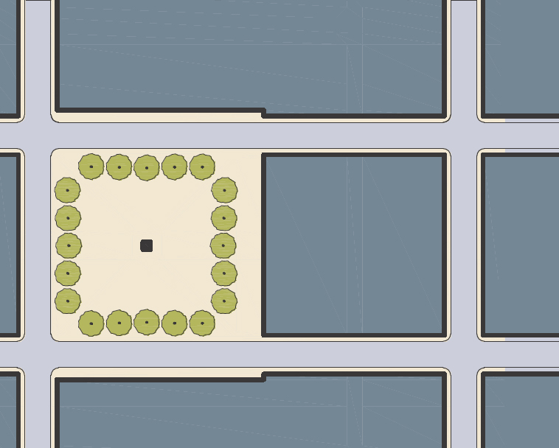

A. Location
Plazas are allowed by right in the T2C, T4, and T5 zones. Plazas shall be defined by a minimum of 150 linear feet of street frontage on at least 1 street. At least 2 edges of plazas should be defined by streets. These spaces are generally located in the middle of a commercial and/or civic district and are adjacent to at least one locally significant street.

B. Size
Plazas shall be a minimum of 0.5 acres and a maximum of 2 acres.

C. Amenities and Facilities
The following facilities and uses should be provided in plazas:
- Drinking Fountains
- Food Concessions, Mobile Vendors, and Micro Retail
- Gazebos and Performance Stages
- Playgrounds
- Fountains and Water Features
- Benches and Planters (that also serve as seat walls)
- Trash and recycle bins
- Pedestrian-Scaled Lighting with fully shielded cutoff devices
- Signage and Kiosks
- Public Art and Interpretive Features
The following facilities and uses shall be allowed by a conditional use permit:
- Amphitheaters

D. Landscaping
Landscaping should be provided in formal patterns and line street edges and open areas. Landscaping should include a variety of tree species planted in tree wells, planters, and/or pots.

E. Parking
There are no parking requirements for plazas.

6. Playground
Playgrounds are small open spaces that are designed and equipped for the recreation of children. These civic spaces shall be defined by streets, building frontages, and other civic spaces. These spaces are sized to serve the specific needs of the users and adjacent civic space (if provided). These civic spaces generally emphasize active recreation for children (i.e. play equipment) and passive recreation for adults supervising the children (i.e. benches). Playgrounds may be fenced off to provide added security and to further define their boundaries.
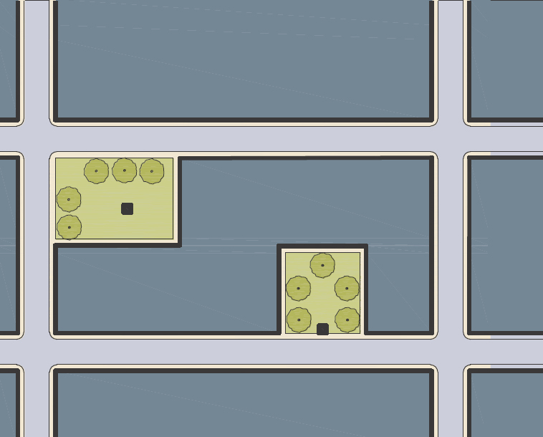

A. Location
Playgrounds are allowed by right in all transects. Playgrounds may be located within regional parks, neighborhood parks, squares, plazas, and as standalone facilities located in neighborhoods. At least 1 edge of standalone playgrounds shall be defined by a street (excluding those located entirely on private property).

B. Size
There are no minimum or maximum size requirements for playgrounds.

C. Amenities and Facilities
The following facilities and uses should be provided in playgrounds:
- Play Equipment
- Drinking Fountains
- Fountains and Water Features
- Benches
- Trash and recycle bins
- Pedestrian-Scaled Lighting with fully shielded cutoff devices
- Bollards
- Signage and Kiosks
- Public Art and Interpretive Features

D. Landscaping
Landscaping may be provided in formal or informal patterns that line the boundaries and/or are interspersed throughout. Landscaping should include trees and may include

E. Parking
Parking spaces are not required for playgrounds.
This page intentionally left blank.

