Facts & Figures

This datasheet serves as the King County Road Services Division’s official reference document for all asset and accomplishment numerical data used for communication purposes during the calendar year. Data about Roads-owned assets and accomplishments changes frequently. For practical purposes, it is necessary to select “moment in time” data to provide to interested parties. This methodology allows for consistency in communication and comparisons over time.

2017-2018 Roads Adopted Budget
Capital Program | $ 43,684,863
Operating Program | $ 85,544,558
Total | $ 129,229,421

County Demographics (2016 data)
 | 2015 | 2016 | Trend
Population of King County | 2,052,800 | 2,105,100
Population of Unincorporated King County | 253,280 | 245,920
The population of King County as a whole is increasing as the population of the unincorporated areas is decreasing. As people continue to move out of the incorporated area, the available tax revenue continues to decrease yet the growing urban population continues to use and place stress on the unincorporated road network to travel between communities.

County Owned Assets (2016 data)
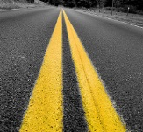  Maintained Centerline Miles  1,467 | Maintained Lane Miles  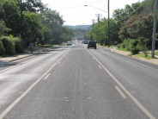  2,967 | Bridges  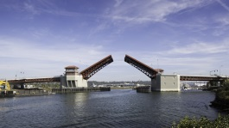  182 | Street Lights  701
Traffic Cameras  52 | Traffic Signals  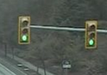  78 | Traffic Control Signs  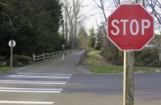  44,442 | Guardrail  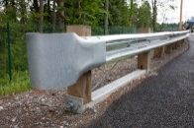  113 miles
Drainage Pipe  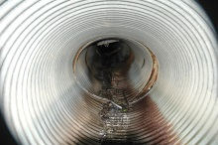  3,256,185 linear feet | Drainage Ditch  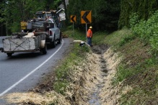  4,728,669 linear feet | Catch Basins  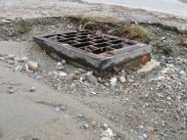  24,502 | Culverts  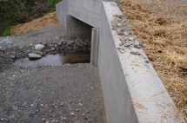  27,832

Accomplishments (2016 data)
 | 2015 | 2016 | Trend
Plowing & Sanding | 2,532 lane miles | 14,567 lane miles
Street Sweeping | 5,934 miles | 5,955 miles
Adopt-a-Road Litter control | 341 miles | 326 miles
Catch basins cleaned | 3209 | 3201
Drainage ditches cleaned | 74,630 feet | 112,720 feet
Road Striping | 2,284 miles | 2,027 miles

