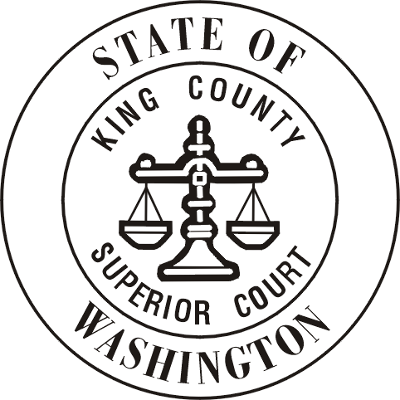
King County Superior Court
Speaker Request Form

PLEASE PRINT OR TYPE
Name of Organization
Contact Name |  |  |  |  |  |  | Email
LAST |  |  |  |  | FIRST
Mailing Address
 |  |  | STREET |  |  | CITY |  |  |  | STATE | ZIP CODE
Contact Phone Number |  |  | ( ) -
Location of Meeting
When Would You Like a Judicial Officer to Speak? |  |  | Preferred Date: Preferred Time:  Alternate Date: Alternate Time:
What Topic Would You Like a Judicial Officer to Address?
The role of the justice system in society
An overview of King County Superior Court functions and programs
Specific legal issues:
Drugs
Family Law
Juvenile Justice
Probate
The role and responsibilities of jurors
How the Court supports access to the system for people who do not have attorneys or speak limited / no English
The Court’s budget and how it is used
Volunteer opportunities within the Court
Other:

Brief Description of Your Organization: (This may help us match you with a judicial officer)

_____________________________________________________________________________________________________

_____________________________________________________________________________________________________

Return to:
King County Superior Court
c/o David Reynolds
516 3rd Avenue, C-203
Seattle, WA 98104
Or email to: David.Reynolds@kingcounty.gov

