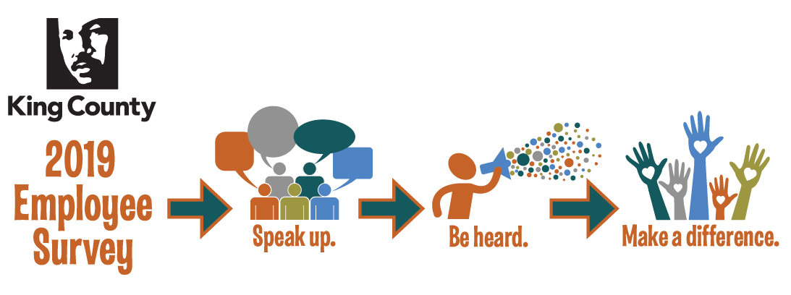
1-2-3 Action Plan Template
Pick 1 Thing – Do 2 Things About it – Communicate 3 Times

Team Information
Action Plan Point Person Name
Brooke Bascom
Action Plan Point Person E-Mail
Brooke.Bascom@kingcounty.gov
Action Plan Team
Brooke Bascom, Vince Vu, Dan Farmer
Workgroup (Department, Division, Section, Unit)
DHR, Career and Culture, Engagement

Pick 1 Thing
Pick something that your team agrees is important and that you can impact in the coming year.
Description of the Action
Recognition
Background for this Action
In our team discussion about the data we identified recognition as a key driver of engagement. Our priorities this year are improving the survey experience and supporting action planning. We will recognize each other for excellent work moving toward these goals. We also talked about what kind of recognition is meaningful for each of us so we know how to recognize each other in a meaningful way. We all like personal, authentic thanks in the form of written notes. We also all felt like it’s nice to have some form of recognition that is visible so you can see it and be reminded of it beyond just the moment it’s given.
Related Survey Question
I receive recognition when I do excellent work
Engagement Dimension (Peer Culture, Personal Influence, Growth and Development, On the Job, Relationship With Supervisor, Division Leadership, Department Leadership, Strategic Alignment, Equity and Social Justice, Well-being)
On the job

Do 2 Things About It
Pick two concrete things that your group will need to do in order to compete your action plan. This should be specific and action oriented. For example: “Have the entire office complete Strengthsfinders Assessment” or “Create new telecommuting policy.” It’s okay if these actions are long term – just make sure you’re actively working on it and communicating. Where possible, try to find alignment with existing activities in your work such as ESJ or continuous improvement.
Action 1
Just in time recognition: Brooke will Create Kudos Kards by end of July that we can give each other when we do excellent work toward our goals. These Kards give an opportunity to for handwritten notes.
Action 2
Major milestone recognition: Vince will create brag board by end of July where big milestones can be called out and celebrated by team members. Milestones will be featured on board for length of time so we can keep appreciating it.

(Over)
Communicate 3 Times
Communication 1
Theme:
Recap of our action plan: what we chose, our planned actions and point people.
This should be a summary of your action plan: What you chose to focus on, what your planned actions are and who is on point to do what.
Due Date: (June – August 2019)
July 24

Communication 2
Theme:
Summary of progress check in. What can we celebrate and what needs adjusting.
This should be a check in about the progress on your action plan.
Due Date: (September – November 2019)
September 30

Communication 3
Theme:
Celebrate our accomplishments and share learning about what we could have done better
This should be a wrap up of what you were able to accomplish and what you learned along the way.
Due Date: (December 2019 – February 2020)
February

