

**Discussion Guide: Leading an Engagement Action Planning Session**

**Planning for the first meeting:**

* **Select a date, time and location. Allow about an hour for your first meeting.**
* **Have a copy of the survey results for each member of your work unit.**

**Sample Agenda:**

1. **Introduction and Purpose:** Why is King County focusing on engagement?
2. **Grasp:** What do the results tell us about the current state of engagement?
3. **Plan:** What will our team do? Who will do what? How will we track progress?
4. **The road ahead:** Next steps on our journey.

**The road ahead: G-PDCA action planning for meaningful impact**

1. **Grasp:** What do the results tell us about the current state of engagement? Ask why 5 times to get to the root cause.
2. **Plan:** What will our team do? Who will do what? How will we track progress?
3. **Do:** Use 1-2-3 Action Planning. Pick 1 thing, take 2 actions and communicate about it at least 3 times.
4. **Check:** Are you moving closer to your goals and how do you know?
5. **Adjust:** Maintain? Implement more widely? Abandon? Try something different?

**Sample Agenda:**

1. **Introduction and Purpose:** Why is King County focusing on engagement?
2. **Grasp:** What do the results tell us about the current state of engagement?
3. **Plan:** What will our team do? Who will do what? How will we track progress?
4. **The road ahead:** Next steps on our journey.

**Discussion Guide**

1. **Introduction and Purpose:** Why is King County Focusing on Engagement?

* King County has a goal to be the Best Run Government. The broad definition of this from our website is:

“It means we are embracing continuous improvement, instituting best management practices, ***empowering employees*** to innovate, and striving for second-to-none customer service.

Every day, we ask ourselves: how can we deliver better services, improve operations, and use fewer resources?  
  
**We listen. We improve. We deliver.”**

* How does our work align to Best Run Government?
* We are focusing on engagement as a strategy to become the Best Run Government to empower employees to bring their full selves to their work. Research shows that with a highly engaged workforce performance goes up and operational costs go down:
  + There is more innovation
  + Productivity goes up
  + Quality goes up
  + Safety incidents go down
  + Absenteeism goes down
  + Turnover goes down
* The goal of this meeting is to build a stronger workplace so we can bring our full selves to the work of becoming the Best Run Government
* We will:
  + Talk about why engagement is important to the county becoming the Best Run Government
  + Examine our survey results so we can GRASP the current state of engagement
  + Pick a thing to work on and develop a PLAN for how to address it
  + Talk about the road ahead and how we are doing to DO the plan, CHECK our progress and ADJUST for maximum impact.
* Every person here is responsible for driving engagement.

1. **Grasp:** What do the results tell us about the current state of engagement?

* Every member of the work unit should get a copy of the report results.
* Explain how to read it. Show how it measures:
  1. How engaged people are (engagement index and the 6 questions related to it)
  2. What drives engagement (key driver questions and questions clustered by drivers)
  3. Comparisons to benchmarks (government benchmark column)
  4. Variation in experience (data that appears in green and red)
* Ask questions like the ones below to encourage discussion:
  1. Do your results on any of these items surprise you?
  2. How do you think people interpreted this particular question?
  3. What would “Strongly Agree” look like for this question?
  4. What are we doing that makes this a strong or weak result?
* Collect thoughts and ideas about the key driver questions and engagement items.
* Help the group narrow its focus to one item that you know the work unit can act on and improve.
* One way of reaching agreement on the item to focus on is to give each work unit member two choices or preferences. Explain that they may use both of their preferences to choose one item.
* Once the group has agreed on an item to focus on discuss what you need to know to further grasp the situation:
  1. Avoid jumping to solutions. Take time to fully grasp the situation so your strategy will be most effective in addressing it.
  2. Ask “Why” 5 times to get to the root cause.
  3. Discuss other sources of data that may need to be collected to truly understand the issue.

1. **Plan**: Create the action plan

* What will your team do?
* Who will do what?
* What will your timeline be?
* How will you track progress?
* How will you celebrate success?

1. **The road ahead**: What comes next: check and adjust

* Discuss the importance of checking and adjusting
* Get ideas about how and when to communicate the action plan and its impacts
* Make plans to reconvene to check progress and celebrate success

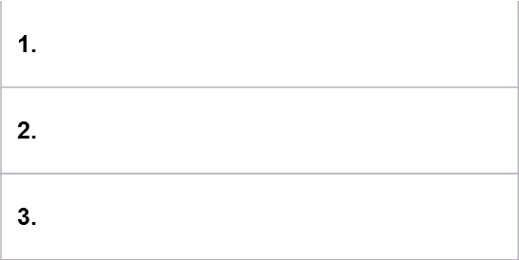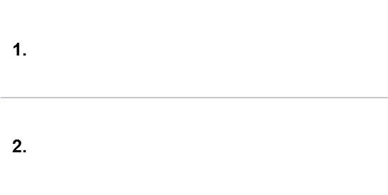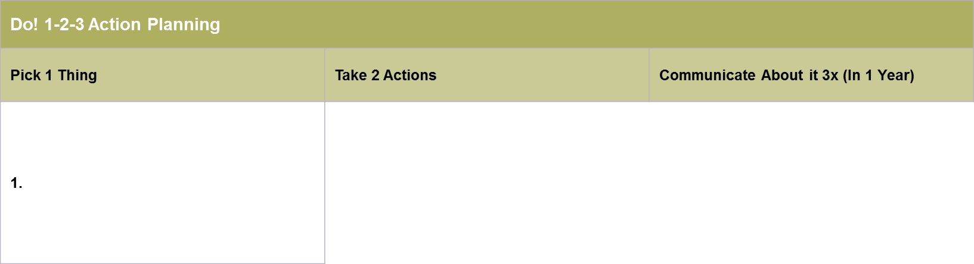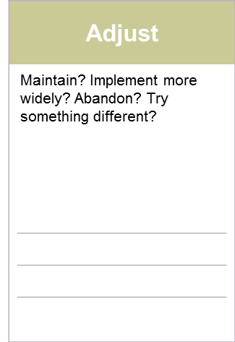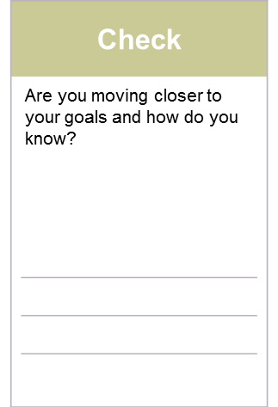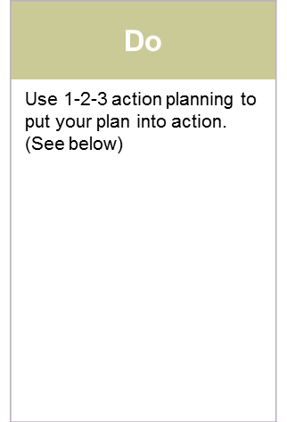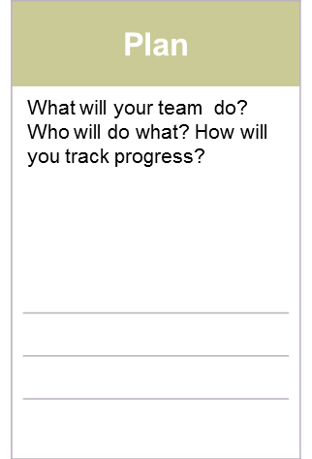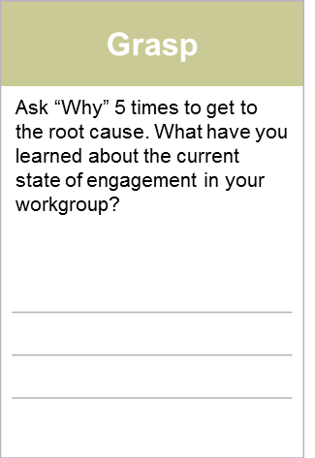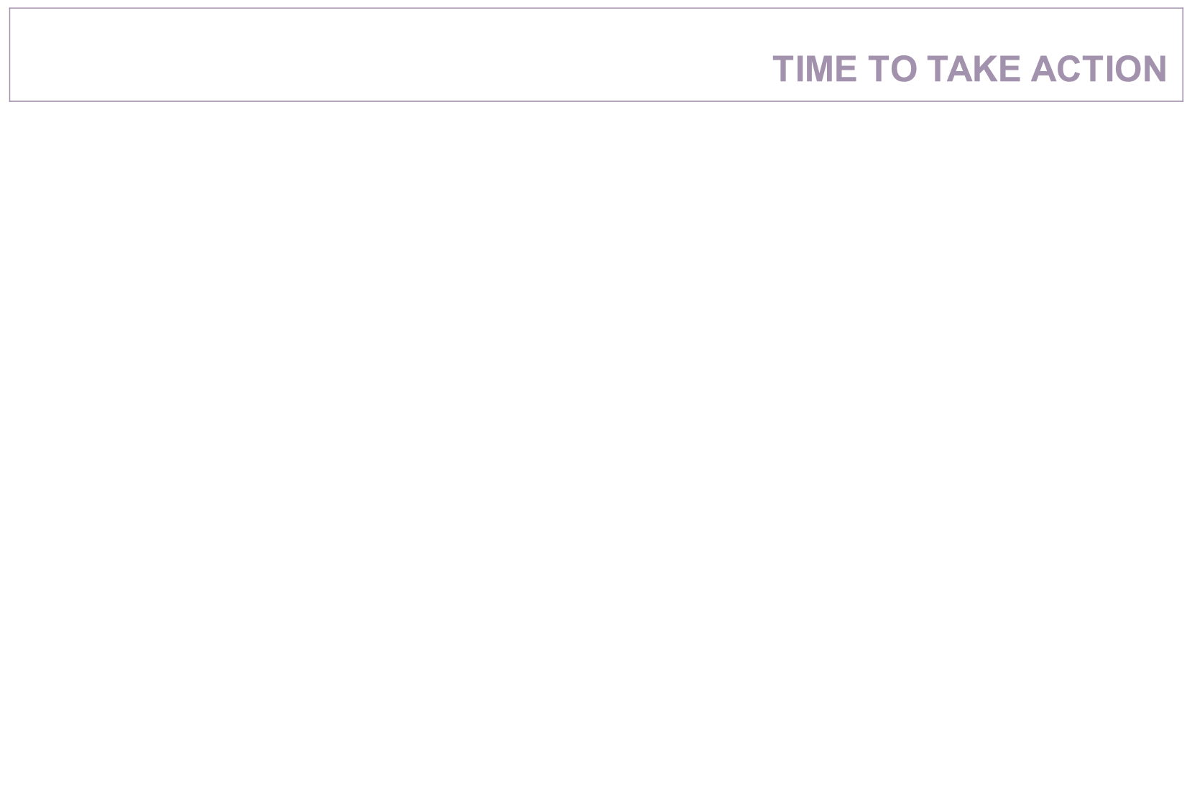

**Do’s and Don’ts**

|  |  |
| --- | --- |
| **Do** | **Don’t** |
| * **Say thank you a million times for speaking the truth (no matter how bad it is)** * **Focus on 1 or 2 issues for the coming year** * **Actively Listen** * **Ask Questions** * **Encourage the group, instead of an individual, to settle on the action plan focus** | * **Ask who said what** * **Ask who participated** * **Force people to speak up** * **Get defensive** * **Feel like you have to say yes or no on the spot** * **Jump to solutions,  take action before really understanding the reports & engaging staff in making meaning of the data** |
|  |  |
|  |  |

**Core Practices of a Skilled Facilitator**

**Stay Neutral** – Focus on the process role of facilitation. Avoid the temptation of offering opinions. Use questions and suggestions to offer ideas that spring to mind – do not improve opinions on the group. Obtain valid information. Have self-awareness.

**Listen Actively and paraphrase** – Use attentive body language. Always make eye contact with the person speaking. Prompt quiet members to participate. Summarize key ideas by paraphrasing for understanding and to let others know they’ve been heard. Allow space for quiet.

**Summarize periodically and synthesize ideas** – listen attentively to everything that is said to include what is unspoken. Offer concise and timely summaries. Summarize when you want to revive a discussion that has ground to a halt. End with a summary as a wrap up. In addition to recording that is said, have the group comment and build on each other’s thoughts. Build consensus and commitment.

**Manage Digression** – actively listen to make sure digression from the topic is actually happening before trying to redirect. Create group norms around this at the beginning of the meeting. Create a parking lot (holding tank) and post prior to the meeting. Bring digression to the attention of the person or group by asking – I’m noticing that we are starting to move to another topic. Does this need to go on the parking lot at this time?

**Manage conflict** – always be in the neutral process role. Avoid entering into conflict with group members. Stay calm, speak slowly, maintain neutral body language. If possible, reframe a polarizing conflict as an issue or a need. Then, use a systematic problem solving approach that gets people working together. Provide structure and be assertive. Ask for concerns and facilitate the group to focus on the facts.

**Ask Questions**