Explore more sustainable
ways of getting to work.
Speak to your Employee
Transportation Coordinator
about the commuting options
that might work for you

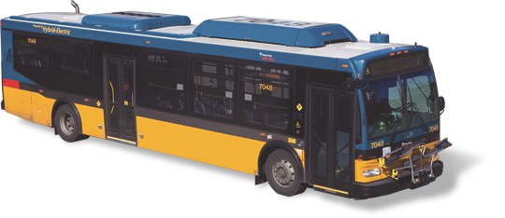Transit
Keep your car at home and leave
the driving to us. Take one of these reliable
and relaxing transit options to work:
• King County Metro buses
• Light rail service
• Commuter rail

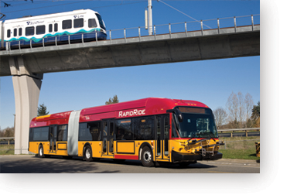
Bike + bus, light rail or train
Ride your bike and connect to more transit
options. Local buses, light rail and trains
have either bike racks or spaces available
for your use. You can also request bike
racks for your vanpool.
Bike or Walk
Reduce your waistline and your carbon
footprint by walking or biking. Many companies and transit centers have bike storage areas available for your use.

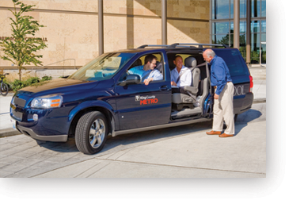
Vanpools
For one monthly price, King County Metro and other transportation agencies provide the van,
gas, insurance and maintenance. You can join an existing vanpool group that fits your needs or you can start your own vanpool group, decide the route and schedule, and find drivers and passengers.

Carpool
Carpooling offers flexibility and savings over driving alone. Plus, two or more people in the
car gives you access to HOV lanes.
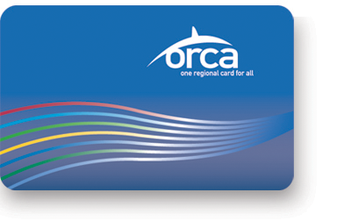
OCRA Card
The ORCA Card is a refillable transportation
fare payment systems that is accepted by six Puget Sound transit agencies. The Washington State Ferry requires a separate monthly fare be loaded. With the ORCA Card you can move quickly and easily between the various transit systems without having to worry about different fares, lost tickets or misplaced transfers.

Commuting options and incentives
offered by your company

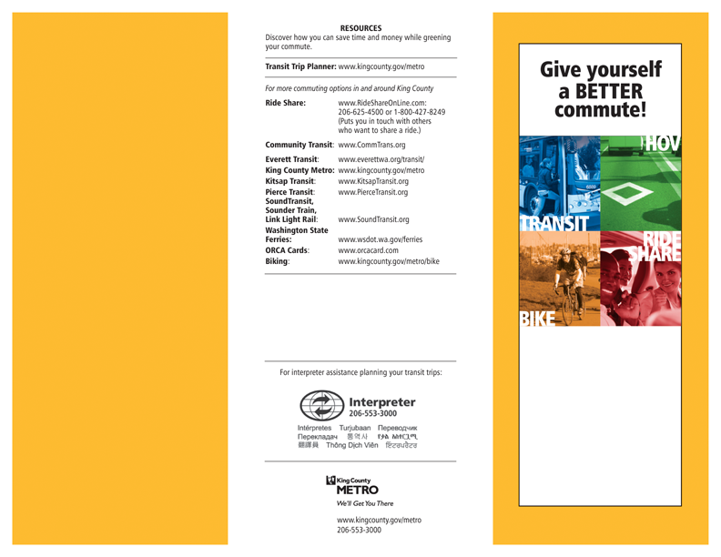
WHAT’S IN IT FOR ME?
Reasons to consider
commuting options:
• Save money
Commuters who use alternative methods of getting to work instead of driving
alone can save from $100 to $200 a month or more. In addition to saving on gas, car maintenance and insurance costs, you can also help reduce taxes. Fewer cars on the road means our streets and highways might not need repair or replacement quite as often.
• Better use of your time
Use your time more productively when sharing the ride.
• Less stress
Sharing the ride to work can reduce your stress level by not having to worry about traffic or finding parking. You can read, sleep, socialize or listen to music instead watching the road.
• More flexibility
You don’t have to rideshare every day. Ridesharing as few as two days a week can make a difference. Choose the
commute option that best fits your work hours, budget and lifestyle.
• It’s good for the environment
You are helping reduce the need for fossil fuels while improving the air quality in the Puget Sound area.

Discover the right
commute solution for you.
Need more information?
Contact your Employee Transportation Coordinator:

