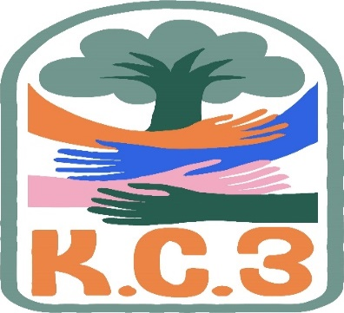
King County Community Collaborative- KC3
Voices of Change and Empowerment
Oct 25th,2022 5:30– 7:30 pm
Virtual meeting
VISION
Together families, youth, communities, and systems will support opportunities to improve the resilience and recovery for all individuals who experience behavioral health challenges. Using an equity lens, we strive to acknowledge and address the disparities within all marginalized communities.

MISSION
Our mission is to create an inclusive space for our community to be heard. In sharing stories of lived experiences, we bring forward the needs, strengths, and opportunities of the current behavioral health system. By taking the challenges and addressing them collectively, we create system change and resolution.

Agenda & Notes
Welcome & Introductions: LeChez-beautiful relaxing slides and music
Invite you to share your name and your role in the chat
If this is your first time and would like to share who you are please feel free too. Dyvena Aguon, social Emotional Facilitator in Renton School District: Devyna.aguon@rentonschools.us
Community Input and Concerns: AAS Human Services-LeChez is looking for an internship/mentoring opportunity 240 hours to learn on the job. Please contact her at: alnbowser94@gmail.com
WSCC has done this in the past. Contact Janice if interested. Devyna may be able to offer something in the school district. LaTonya shared BHRD may have opportunities around training/events, TAY population
Presentation: Susan Schoeld, Crisis Triage Administrator Crises and Connection 988/Diane Mayes, Clinical Director with Crisis Connections
- New crisis line live July 15th.
- 3 call centers in the state, Crisis Connections-King, Volunteers of America-North, Frontier BH-Spokane Lifeline Center
- rates for answer rate 40% and now they are much higher
- 2000 calls per month, higher acuity, red cases are those they need to call 911 or other immediate support-though these are fewer
- Some calls were being rerouted to different counties due to phone number area code of caller being registered to a different county-they can still mange call or transfer to call center closer to where they live
  - Steering committee in session for technology issues to be approved at the legislative level
- MOU in place with KC to help clients get connected to providers
- Map of crisis centers. Regional lines are still operational
- DCRs are ramping up teams—need to meet criteria for immediate risk, CCORS, mobile response are other resources
Sharing Announcements, Updates: All are welcome to share

There is a great opportunity for young people ages 14-24 to share their voices on the Washington State Education System. All participants will receive a $60 gift card at the end of the 3 hour session. Here is the link for registration.
Counties: King to be scheduled, Pierce, Spokane, Thurston and Yakima. Additionally, we'll be holding a virtual Listening Session for those who live outside these counties.
Registration and information link:
https://forms.office.com/pages/responsepage.aspx?id=9iPH_j-sMEiVwboa1PuDVZGPe9UA5B1EsfgxyER7R5tUMVdaRThKM01FMTJTWTJJVTAzV0IySFpXSi4u

Jones Community Solutions, Muslim American Youth Association, Council members Rep Orewall listening session-How do we get more youth and families to give input—what’s going to happen with the feedback. Cole is part of the workgroup.
A Common Voice-role is to support parents and family/peers who are navigating systems/Support groups twice a month/Trainings-free Family Peer Consultation 10/27 @ 5:00pm-6:30pm....11/1 Parent & Care Givers 10:00am and 11/8....4:00pm-5:30pm.
WA DADS Hiring Peers across WA state: contact Nelson Rascon for more info: <nrascon@dadsmove.org>
Update:
GPS: https://www.guidedpathways.org/
Fall party on Friday open to the community! Crafts, games, food!
Recruiting volunteers for various workgroups
BECCA-Melody has been attending workgroup

WSCC: Newsletter https://wsccsupport-8458277.hs-sites.com/october2022
Karen Kelly-recently diagnosed with Cancer, having some setbacks, she is very public about what is going on, would love for folks to reach out. Statewide meeting tomorrow 4:30-6:30pm (4 committees/workgroups) primarily for families raising children with high needs. Can receive honorarium up to $50 per session.
SUD Family Navigator Trainings in Nov and Dec

Workgroups:
Youth Engagement: Still meeting monthly. General support for the community sharing resources, projects have slowed
Membership Workgroup: still trying to form, are there interested parties? How can we engage more families?

KC3 engagement Activity Time; Game: Scavenger hunt!
Thank you for attending. Be safe, stay well. Next meeting Nov 22,2022

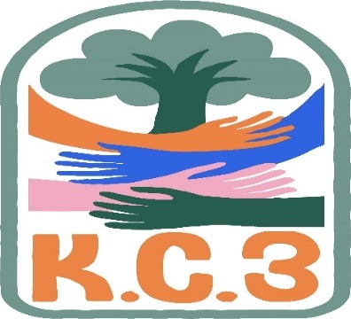

King County Community Collaborative- KC3
Voices of Change and Empowerment
Comfort Agreement

Stay on task
No side conversations
Cell phones on silent
Safe learning environment
Be willing to give and receive feedback
Leave your agency hat at the door. Bring your experience expertise and commitment.
Remember we all bring the best intentions to our work
Value everyone’s opinion
Ask questions and check out your assumptions and thinking
Listen carefully
Let your voice be heard
Provide space to hear about immediate concerns
Seek common ground and action
Identify areas of continued debate and defer to another day
If dissenting, offer an alternative
Be clear about discussion versus decision-making
Start meetings on time
Observe time frames

King County Community Collaborative KC3
Voices of Change and Empowerment
Regional FYSPRT

Safety Plan

If anyone during the meeting begins to feel uneasy or frustrated:
- First take a break, Leave the room if needed, and use the coping skills that are familiar to you
- Second reach out to support people in the room
- Third, Tri-leads will offer support to anyone who signals distress-emotionally or otherwise.
- Lastly, reach out to those in the room who have background n de-escalation (all Tri-leads, Convener, Mental Health Provider
KC3 Tri-leads will identify exits for members and attends will know how to safely exit the room if needed
KC3 members and attendees agree to be present, aware and know who in the room (i.e. Tri-leads, Metal Health Providers individuals trained in de-escalation).
KC3 Tri-leads and welcome committee will offer breaks to the group and individuals if conversations get heated or someone is signaling discomfort or distressed,
If Aggressive behavior is present and you have no experience with de-escalation techniques, please find an exit and leave the room.
- IF you do have de-escalation experience you may provide support if you feel comfortable with this. If you feel unsafe or prefer to not engage with an aggressive individual, please find safe space and/or exit the room.

Sharing Resources and information for Families

PAVE pave+wapave.org@ccsend.com

