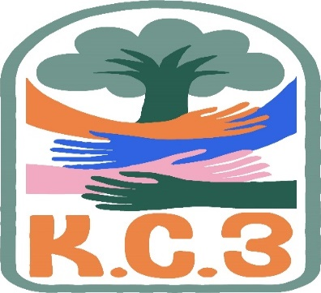
King County Community Collaborative- KC3
Voices of Change and Empowerment
February 28th,2023
Virtual meeting
VISION
Together families, youth, communities, and systems will support opportunities to improve the resilience and recovery for all individuals who experience behavioral health challenges. Using an equity lens, we strive to acknowledge and address the disparities within all marginalized communities.

MISSION
Our mission is to create an inclusive space for our community to be heard. In sharing stories of lived experiences, we bring forward the needs, strengths, and opportunities of the current behavioral health system. By taking the challenges and addressing them collectively, we create system change and resolution.

Agenda
***Notes for this meeting will be highlighted within the agenda***
Welcome & Introductions: Candace (20mins as we allowed for more participants to join and explored potential technological difficulties)
Invite you to share your name and your role in the chat
If this is your first time and would like to share who you are please feel free too.

Candance Hunsucker – System Partner (KC3 Tri-Lead)
Dae – System Partner
Michelle Tinkler – System Partner
Abby Cantarell – System Partner
Connor Lenz - System Partner
Jackie Berganio - System Partner
Rachel Castiglia - System Partner
LeChez Bowser - System Partner (KC3 Tri-Lead)
Lisa
Cole Devlin - System Partner (KC3 Tri-Lead)
LaTonya Rogers - System Partner (KC3 Convenor)

Community Input and Concerns: CLIP approvals & Service Gaps
Presentation: Michelle Tinkler – OBHA presentation on new ombudsman program (20mins)
Learning about the history of behavioral health ombuds. Works independently from the state and protects interests of individuals in Washington experiencing challenges in public and private behavioral health systems.
All team members are Peers with lived behavioral health experiences. Rights are honored with advocacy, inclusion, and collaboration. Concerns are addressed according to federal and state laws providing oversight.
Educates consumers and providers and provides recommendations to support improvement in quality of care.
Refer and track grievances. Works across all ten regions win Washington state. Forums are via zoom to accommodate this.
Promotes self-advocacy and empowers individual voice. Services provides to adults, youth, families, and minors. Aims to resolve concerns at the lowest level possible. Covers various categories for complaints and grievances. They do not give legal advice. Open door policy for eligibility. All free of charge and confidential.
PowerPoint with contact information shared with KC3 to share with interested parties. Q&A was open.
More can be learned on their website obhadvocacy.org along with forums for community input (flyer will also be shared with distribution list)

Connor Lenz – Presentation on legislative developments in becca (65mins)
BECCA in King County and legislative history Pre-BECCA.
Most of the content from this presentation centered around the past six years due to their impacts.
BECCA Law first implemented in 1995.
Learning the difference between ARY & CHINS compared to other juvenile court matters.
Discussions of attendance and truancy issues for youth in school and how it can result in juvenile cases.
Discussion of FINS (Family in Need of Services)
Issues with not having enough CRCs to support youth, not enough services as required by law to provide.
Bill has been passed with good intentions, but youth are not yet being served as required by law.
Discussion of youth trafficking concerns in relation to HB 1775.
Shared King County efforts to support youth and family in BECCA.
Someone shared their lived experience with ARY and not having a positive experience. Like being put in a jumpsuit and not fully understanding what’s happening. Offering resources for youth so they better understand the interventions and the hope to support youth to get back on track. Raising matters to work with the family alongside with youth so it’s not just youth being taken from home with no changes to the home. Connor was validating and willing to discuss differences in how regions handle matters and changes in law to address cracks in the system. Hopes to prevent court orders which can result in detention visits.
PowerPoint and contact shared with KC3 to share with distribution list.

Sharing Announcements, Updates: All are welcome to share (20mins)
Update: Public Health will be doing a workshop on drug use to help prevent overdose (flyer shared with group)
Someone shared need to discuss fentanyl use and its impact on this generation
Discussions around how to utilize the space at KC3, bringing agendas to the meeting, topics, etc. Being a part of the community and no longer feeling like its against you. Expressing gratitude for this space and the opportunity to have your voice heard!
GPS
WSCC
Workgroups:
Needs Assessment / Workplan
Youth Engagement
KC3 engagement Activity Time; Black History Month Jeopardy (Will be playing this next month so more people have the opportunity to play and learn)
Thank you for attending. Be safe, stay well. Next meeting March 28th,2023
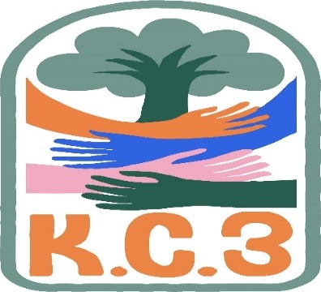

King County Community Collaborative- KC3
Voices of Change and Empowerment
Comfort Agreement

Stay on task
No side conversations
Cell phones on silent
Safe learning environment
Be willing to give and receive feedback
Leave your agency hat at the door. Bring your experience expertise and commitment.
Remember we all bring the best intentions to our work
Value everyone’s opinion
Ask questions and check out your assumptions and thinking
Listen carefully
Let your voice be heard
Provide space to hear about immediate concerns
Seek common ground and action
Identify areas of continued debate and defer to another day
If dissenting, offer an alternative
Be clear about discussion versus decision-making
Start meetings on time
Observe time frames

King County Community Collaborative KC3
Voices of Change and Empowerment
Regional FYSPRT

Safety Plan

If anyone during the meeting begins to feel uneasy or frustrated:
- First take a break, Leave the room if needed, and use the coping skills that are familiar to you
- Second reach out to support people in the room
- Third, Tri-leads will offer support to anyone who signals distress-emotionally or otherwise.
- Lastly, reach out to those in the room who have background n de-escalation (all Tri-leads, Convener, Mental Health Provider
KC3 Tri-leads will identify exits for members and attends will know how to safely exit the room if needed
KC3 members and attendees agree to be present, aware and know who in the room (i.e. Tri-leads, Metal Health Providers individuals trained in de-escalation).
KC3 Tri-leads and welcome committee will offer breaks to the group and individuals if conversations get heated or someone is signaling discomfort or distressed,
If Aggressive behavior is present and you have no experience with de-escalation techniques, please find an exit and leave the room.
- IF you do have de-escalation experience you may provide support if you feel comfortable with this. If you feel unsafe or prefer to not engage with an aggressive individual, please find safe space and/or exit the room.

Sharing Resources and information for Families

