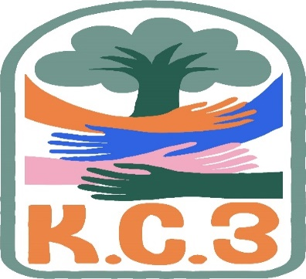
King County Community Collaborative- KC3
Voices of Change and Empowerment
May 23rd, 2023
Virtual meeting
VISION
Together families, youth, communities, and systems will support opportunities to improve the resilience and recovery for all individuals who experience behavioral health challenges. Using an equity lens, we strive to acknowledge and address the disparities within all marginalized communities.

MISSION
Our mission is to create an inclusive space for our community to be heard. In sharing stories of lived experiences, we bring forward the needs, strengths, and opportunities of the current behavioral health system. By taking the challenges and addressing them collectively, we create system change and resolution.

Agenda
Welcome & Introductions: LeChez
Invite you to share your name and your role in the chat 10 in attendance
If this is your first time and would like to share who you are please feel free too.
Community Input and Concerns: A community concern was addressed around community needs for childcare, which Pattie shared she will look into past meeting notes to see what was previously brought to this space around potential gaps and brainstorming community supports.
Concern was brought to this space around having trouble with KC WISe agencies not prioritizing CLIP discharged youth. Sandy T. and Pattie M. suggested we bring this concern to the upcoming KC WISe Collaborative meeting to follow-up on this community concern, which LeChez B. will follow up with to bring any updates learned to our next scheduled KC3 meeting in June.
This conversation also evolved into a discussion around which networks in our behavioral health system operate with extended hours to better meet the needs of youth and families in our community, with Dad’s Move discussing their own efforts to be flexible and meet on evenings and weekends as needed. KC3 will follow up with the community (intended to be a survey) to see which other networks offer flexible options for families (including options to meet via Zoom/virtually).
Staffing shortage for behavioral health services was addressed, and brainstorming continues within KC3 around networking for community supports, including the availability of afterhours clinics/resources.
Tri-Lead Retreat Planning – What should our Tri-Leads be focusing on for KC3?
Community input from KC3 shared, with considerations for a shift in the KC3 contract, it would be helpful to understand who are the KC3 Tri-Leads and re-orienting them with responsibilities as determined by the regional FYSPRT Manuel. KC3 community input also suggests that the KC3 Tri-Lead leadership focus on building skills around facilitation and recruitment skills which align with trauma informed care and DEI principles.
Family Youth Professional Partnership Picnic – Event planning
Initiated conversations around community support for this event, volunteers and recruitment of community skillsets and strengths.
Presentation: Needs Assessment Data Review – KC3
Community provided input with connections made between our KC3 workplan goals and the needs assessment data previously collected. Community valued having a space to review these connections.
Sharing Announcements, Updates: All are welcome to share
NAMI Walk – At Marina Park, June 3rd, 8am-11am – Interest in T-shirts
Melody P. and LeChez B. shared updates with the community around NAMI Walk 2023
Resources for youth and camps under resource sharing
Update:
GPS Melody P. shared about Community Game Night and Guided Good Choices
WSCC
Workgroups:
Needs Assessment / Workplan Discussed in our presentation and we will continue to address the updating of our workplan goals in relation to the needs assessment data within future KC3 meetings, especially as we prepare for contract changes and the end of the fiscal year.
Youth Engagement
KC3 engagement Activity Time – KC3 community collectively chose to end this meeting around 7pm due to others who had to leave early, choosing to save our activity for next month.
Thank you for attending. Be safe, stay well. Next meeting June 27th, 2023
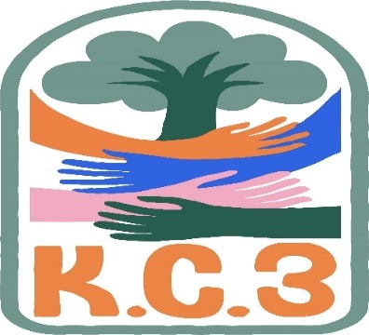

King County Community Collaborative- KC3
Voices of Change and Empowerment
Comfort Agreement

Stay on task
No side conversations
Cell phones on silent
Safe learning environment
Be willing to give and receive feedback
Leave your agency hat at the door. Bring your experience expertise and commitment.
Remember we all bring the best intentions to our work
Value everyone’s opinion
Ask questions and check out your assumptions and thinking
Listen carefully
Let your voice be heard
Provide space to hear about immediate concerns
Seek common ground and action
Identify areas of continued debate and defer to another day
If dissenting, offer an alternative
Be clear about discussion versus decision-making
Start meetings on time
Observe time frames

King County Community Collaborative KC3
Voices of Change and Empowerment
Regional FYSPRT

Safety Plan

If anyone during the meeting begins to feel uneasy or frustrated:
- First take a break, Leave the room if needed, and use the coping skills that are familiar to you
- Second reach out to support people in the room
- Third, Tri-leads will offer support to anyone who signals distress-emotionally or otherwise.
- Lastly, reach out to those in the room who have background n de-escalation (all Tri-leads, Convener, Mental Health Provider
KC3 Tri-leads will identify exits for members and attends will know how to safely exit the room if needed
KC3 members and attendees agree to be present, aware and know who in the room (i.e. Tri-leads, Metal Health Providers individuals trained in de-escalation).
KC3 Tri-leads and welcome committee will offer breaks to the group and individuals if conversations get heated or someone is signaling discomfort or distressed,
If Aggressive behavior is present and you have no experience with de-escalation techniques, please find an exit and leave the room.
- IF you do have de-escalation experience you may provide support if you feel comfortable with this. If you feel unsafe or prefer to not engage with an aggressive individual, please find safe space and/or exit the room.

Sharing Resources and information for Families

Camp Erin: Camp Erin®-King County is a free, weekend, overnight camp for youth who are grieving the death of a significant person in their lives. Children and teens ages 6 to 17 (or 18 if still in school) attend a weekend camp experience that combines grief education and emotional support with fun, traditional camp activities. Camp will be held in Ravensdale, Washington from June 2nd – June 4th. If you have any questions regarding camp please reach out to Alex Tarasar – Camp Erin Clinical Coordinator, 206-473-8934
https://forms.office.com/Pages/ResponsePage.aspx?id=hpAxLiaao0aGX2Fb7Vdnhiu9PwEhm_tNpsgyC7HNDfxURDUwRlZTSEZIUjUwWTlYNUw0Ujc5RkFVUyQlQCN0PWcu

Registration for the Rites of Passage Experience is now open! This experience is for girls between the ages of 11-19 and will be hosted July 1 & 2 at Camp Long. This is a wonderful opportunity for young people who want to learn life skills, do community service, be partnered with a mentor, and much much more! All participants will receive a $50.00 gift card! To Register, join us at Sankofa Theatre on May 13 from 6:00-8:00 pm, or call us at 206-722- 6602.

https://www.seattleymca.org/social-impact-center/youth-young-adults/violence-prevention-intervention

https://youngwomenempowered.org/our-programs/?mc_cid=2244d7a69f&mc_eid=f7b133c87f

https://www.parentmap.com/calendar?utm_source=newsletter&utm_medium=email&utm_content=MORE%20FUN%20THIS%20WEEK%20%E2%96%BA&utm_campaign=parentmap-latest-east-05-15-2023

