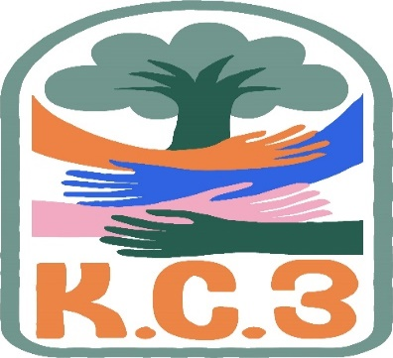
King County Community Collaborative- KC3
Voices of Change and Empowerment
April 25th, 2023
Virtual meeting
VISION
Together families, youth, communities, and systems will support opportunities to improve the resilience and recovery for all individuals who experience behavioral health challenges. Using an equity lens, we strive to acknowledge and address the disparities within all marginalized communities.

MISSION
Our mission is to create an inclusive space for our community to be heard. In sharing stories of lived experiences, we bring forward the needs, strengths, and opportunities of the current behavioral health system. By taking the challenges and addressing them collectively, we create system change and resolution.

Agenda
Welcome & Introductions: LeChez
Invite you to share your name and your role in the chat 14 in attendance
If this is your first time and would like to share who you are please feel free to. A youth volunteer with GPS (high school student) was in attendance for the first time..
Community Input and Concerns: Sandy Tomlin’s input was a thank you to all who contributed to the Work Plan. Pattie offered to do a quick review towards the end of the meeting.
Presentation: No presentations this month.
Sharing Announcements, Updates: All are welcome to share
Summer Camp opportunities under resource sharing
Update: A discussion was started about DCYF being more “hands off” with youth. There is a concern foster youth are not getting their needs met. Cole stated the YMCA is very helpful and he is concerned about other organizations with less support.
GPS- Melody reported that Nami had a walk kick-off meeting. We plan to have a GPS group with matching t-shirts. The event is at Marina Park in Kirkland on Saturday, June 3rd.
WSCC- There was no representation for WSCC and Pattie Marshall gave announcements on their behalf. She reported their Children’s Behavioral Health Summit begins Monday, April 1st and concludes Tuesday, April 2nd. They are meeting with parents only on the 2nd to discuss a “family Training Academy.” Pattie and two of her staff plan to attend.
Workgroups:
Needs Assessment / Workplan-Pattie and LeChez shared the work plan and offered input on areas of focus, providing insights on areas of focus for the workplan goals. Discussing the goals outlined on our regional FYSPRT's Workplan and sharing the progress we've made towards those goals during this past Jan-Mar quarter. Also sharing how the KC3 would love more input from others throughout the quarter about any efforts on their part which is in alignment with the workplan goals, because it would be beneficial to capture that for future quarterly reports.
Youth Engagement- Cole shared information about Nami Youth Eastside Conference which is happening April 28th in Redmond. He will be a speaker.
KC3 engagement Activity Time- LeChez created a Jeopardy game around random facts in the categories of music, geography, math, etc. Cole won-beating Jenapher by 200 points. Much to his surprise!
Thank you for attending. Be safe, stay well. Next meeting May 23rd, 2023
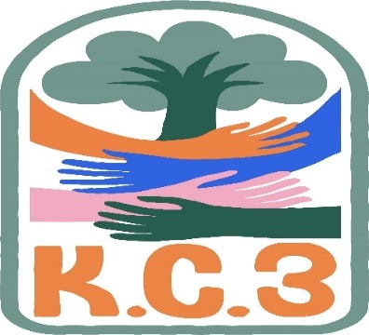

King County Community Collaborative- KC3
Voices of Change and Empowerment
Comfort Agreement

Stay on task
No side conversations
Cell phones on silent
Safe learning environment
Be willing to give and receive feedback
Leave your agency hat at the door. Bring your experience expertise and commitment.
Remember we all bring the best intentions to our work
Value everyone’s opinion
Ask questions and check out your assumptions and thinking
Listen carefully
Let your voice be heard
Provide space to hear about immediate concerns
Seek common ground and action
Identify areas of continued debate and defer to another day
If dissenting, offer an alternative
Be clear about discussion versus decision-making
Start meetings on time
Observe time frames

King County Community Collaborative KC3
Voices of Change and Empowerment
Regional FYSPRT

Safety Plan

If anyone during the meeting begins to feel uneasy or frustrated:
- First take a break, Leave the room if needed, and use the coping skills that are familiar to you
- Second reach out to support people in the room
- Third, Tri-leads will offer support to anyone who signals distress-emotionally or otherwise.
- Lastly, reach out to those in the room who have background n de-escalation (all Tri-leads, Convener, Mental Health Provider
KC3 Tri-leads will identify exits for members and attends will know how to safely exit the room if needed
KC3 members and attendees agree to be present, aware and know who in the room (i.e. Tri-leads, Metal Health Providers individuals trained in de-escalation).
KC3 Tri-leads and welcome committee will offer breaks to the group and individuals if conversations get heated or someone is signaling discomfort or distressed,
If Aggressive behavior is present and you have no experience with de-escalation techniques, please find an exit and leave the room.
- IF you do have de-escalation experience you may provide support if you feel comfortable with this. If you feel unsafe or prefer to not engage with an aggressive individual, please find safe space and/or exit the room.

Sharing Resources and information for Families

Camp Erin: Camp Erin®-King County is a free, weekend, overnight camp for youth who are grieving the death of a significant person in their lives. Children and teens ages 6 to 17 (or 18 if still in school) attend a weekend camp experience that combines grief education and emotional support with fun, traditional camp activities. Camp will be held in Ravensdale, Washington from June 2nd – June 4th. If you have any questions regarding camp please reach out to Alex Tarasar – Camp Erin Clinical Coordinator, 206-473-8934
https://forms.office.com/Pages/ResponsePage.aspx?id=hpAxLiaao0aGX2Fb7Vdnhiu9PwEhm_tNpsgyC7HNDfxURDUwRlZTSEZIUjUwWTlYNUw0Ujc5RkFVUyQlQCN0PWcu

Registration for the Rites of Passage Experience is now open! This experience is for girls between the ages of 11-19 and will be hosted July 1 & 2 at Camp Long. This is a wonderful opportunity for young people who want to learn life skills, do community service, be partnered with a mentor, and much much more! All participants will receive a $50.00 gift card! To Register, join us at Sankofa Theatre on May 13 from 6:00-8:00 pm, or call us at 206-722- 6602.

