Face masks are required
in all areas where patients or clients are present.
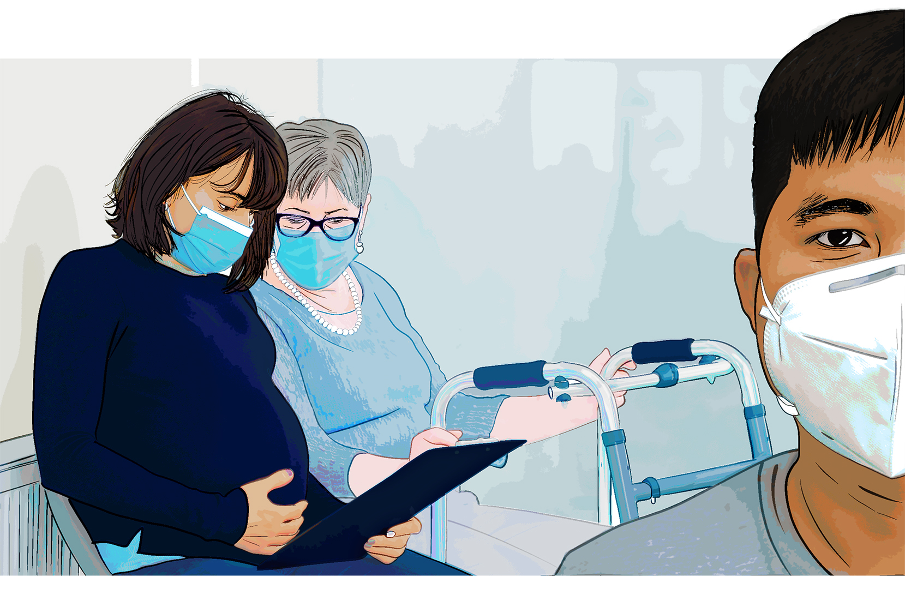

Please help protect our patients and employees

