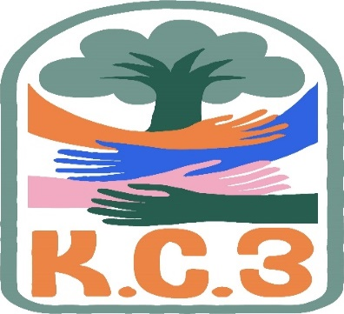
King County Community Collaborative- KC3
Voices of Change and Empowerment
Nov 22,2022 5:30– 7:30 pm
Meeting Notes
VISION
Together families, youth, communities, and systems will support opportunities to improve the resilience and recovery for all individuals who experience behavioral health challenges. Using an equity lens, we strive to acknowledge and address the disparities within all marginalized communities.

MISSION
Our mission is to create an inclusive space for our community to be heard. In sharing stories of lived experiences, we bring forward the needs, strengths, and opportunities of the current behavioral health system. By taking the challenges and addressing them collectively, we create system change and resolution.

Agenda
Candace Facilitating/LeChez Notetaking
Welcome & Introductions: (20mins)
Invite you to share your name and your role in the chat
- Rachel Castiglia, CLIP liaison with Molina Healthcare
- Abby Cantarell - Children's BH Administrator with Coordinated Care
- Jackie Hopkins, WSCC Family Navigator Trainer (SUD)
- Melody Parshall-Guided Pathways-Support for Youth and Families
- Jessica Gudino, CPC with GPS
- Candace Hunsucker, System tri lead, Community Health Plan of WA
- Sandy Tomlin, KC BHRD, Wraparound & CLIP Laison
- LeChez Bowser - KC3 Youth Tri-Lead and CPC
- Janice Schutz Executive Director Washington State Community Connectors
- Tony Reda Lead Parent Support Specialist, Serving King, Pierce, Thurston-Mason Counties A Common Voice C.O.P.E. Project
- Cole Devlin (he/they) - Co-Youth Tri-Lead for KC3. Co-President of Board for SPARK Peer Learning Center. Child and Family Therapist: Intensive Services (WISe) for Y Social Impact Center.
- Dae - OBHA - king county ombus
- Karen Kelly (she/her) - WSCC Project Director - Organization Rep and Family Voice
- Pattie Marshall / Guided Pathways ED /Peer /Parent
If this is your first time and would like to share who you are please feel free too.
Community Input and Concerns: (5mins)
Great Christmas resource for trans youth! Transanta.org
Presentation: OBHA- Dea Degrate, Behavioral Health Advocate (20mins)
- Dae was able to go over the highlights of the OBHA presentation and answer questions about her role, their work with peers, and partnering for community work as behavioral health advocates.
- Dae took emails from attendees in the chat to share the PowerPoint presentation and flyers
- OBHA aims to be out in the community and spread services or pass resources along. Project newly began in September and only plan to expand.
Sharing Announcements, Updates: All are welcome to share
Update: (35mins)
GPS
Youth MOVE Chapter will be continuing. Working towards being a more open community space with a robust calendar of groups to look forward to. Looking for volunteers and youth/family/community input.

WSCC
WSCC Statewide Family Network Meeting Monday 11/28, noon- 2 PM.
We will be presenting updates form the National Federation of Families conference.
Pleases join us. Register in advance for this meeting:
https://wsccsupport-org.zoom.us/meeting/register/tZAsceGgrzkpGdL8UeH-WEqRyRC1MdEMwriD

Working to repopulate their workgroups. Looking for parents with recent lived experience to better understand what’s working and what isn’t with behavioral health services

KC3 requested to spread word around upcoming trainings hosted by WSCC. All trainings are interactive. Trainings are open for anyone but more directed towards parents and caregivers.

WSCC is hoping to gather feedback around the providing of these trainings:
https://www.surveymonkey.com/r/2023FYSPRT-TANeeds

Workgroups: (10mins)
HCA Office of Recovery Partnerships:
Steering Committee applications are still being accepted. We are particularly interested in hearing from our communities on the Eastern side of the state as well as those who identify as LGBTQ+, Hispanic, and our Veterans and Tribal communities. The steering committee is open to anyone who self-identifies with having lived experience with Behavioral Health, no “title” is needed to apply, no “professional” experience, and you do not need to have “official” leadership experience; leaders are woven within all aspects of our shared communities, your experience as someone who self identifies as having lived experience and your passion for creating systems that represent, honor and uplift our communities are all that is needed. Join us in building a better, stronger, truly representative, culturally honoring, and sustainable Behavioral Health system that works for ALL!

https://www.hca.wa.gov/assets/program/orp-steering-committee-application.pdf

Youth Engagement
Youth engagement subcommittee is taking a short hiatus for the holidays
Send potential members Cole’s way
(sharing the KC3 flyer for more youth and family engagement)
Membership
KC3 preparing to bring in a new youth Tri-Lead and Cole will be moving into the System Tri-Lead role
KC3 engagement Activity Time; Game night (30mins)
Thank you for attending. Be safe, stay well. No meeting in December
See you all in 2023
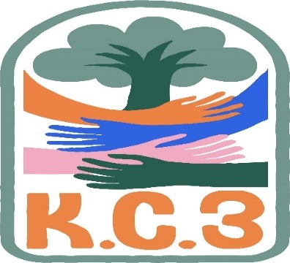

King County Community Collaborative- KC3
Voices of Change and Empowerment
Comfort Agreement

Stay on task
No side conversations
Cell phones on silent
Safe learning environment
Be willing to give and receive feedback
Leave your agency hat at the door. Bring your experience expertise and commitment.
Remember we all bring the best intentions to our work
Value everyone’s opinion
Ask questions and check out your assumptions and thinking
Listen carefully
Let your voice be heard
Provide space to hear about immediate concerns
Seek common ground and action
Identify areas of continued debate and defer to another day
If dissenting, offer an alternative
Be clear about discussion versus decision-making
Start meetings on time
Observe time frames

King County Community Collaborative KC3
Voices of Change and Empowerment
Regional FYSPRT

Safety Plan

If anyone during the meeting begins to feel uneasy or frustrated:
- First take a break, Leave the room if needed, and use the coping skills that are familiar to you
- Second reach out to support people in the room
- Third, Tri-leads will offer support to anyone who signals distress-emotionally or otherwise.
- Lastly, reach out to those in the room who have background n de-escalation (all Tri-leads, Convener, Mental Health Provider
KC3 Tri-leads will identify exits for members and attends will know how to safely exit the room if needed
KC3 members and attendees agree to be present, aware and know who in the room (i.e. Tri-leads, Metal Health Providers individuals trained in de-escalation).
KC3 Tri-leads and welcome committee will offer breaks to the group and individuals if conversations get heated or someone is signaling discomfort or distressed,
If Aggressive behavior is present and you have no experience with de-escalation techniques, please find an exit and leave the room.
- IF you do have de-escalation experience you may provide support if you feel comfortable with this. If you feel unsafe or prefer to not engage with an aggressive individual, please find safe space and/or exit the room.

Sharing Resources and information for Families

PAVE pave+wapave.org@ccsend.com

