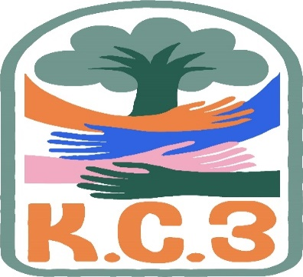
King County Community Collaborative- KC3
Voices of Change and Empowerment
June 27th, 2023
Virtual meeting
VISION
Together families, youth, communities, and systems will support opportunities to improve the resilience and recovery for all individuals who experience behavioral health challenges. Using an equity lens, we strive to acknowledge and address the disparities within all marginalized communities.

MISSION
Our mission is to create an inclusive space for our community to be heard. In sharing stories of lived experiences, we bring forward the needs, strengths, and opportunities of the current behavioral health system. By taking the challenges and addressing them collectively, we create system change and resolution.

Agenda
Welcome & Introductions: Melody
Invite you to share your name and your role in the chat
If this is your first time and would like to share who you are please feel free too.
Community Input and Concerns:
Family Youth Professional Partnership Gathering – Event planning
Follow up – KC WISe referrals from CLIP discharges
Presentation: Happy Pride Month! – KC3
Sharing Announcements, Updates: All are welcome to share
Update:
GPS
WSCC

Workgroups:
Needs Assessment / Workplan – Reworking our goals (prioritizing areas of focus)
Youth Engagement
KC3 engagement Activity Time – The Price is Right
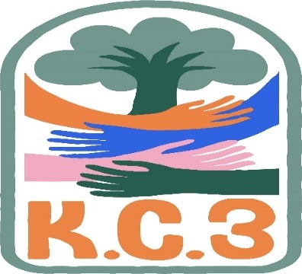
Thank you for attending. Be safe, stay well. Next meeting July 25th, 2023

King County Community Collaborative- KC3
Voices of Change and Empowerment
Comfort Agreement

Stay on task
No side conversations
Cell phones on silent
Safe learning environment
Be willing to give and receive feedback
Leave your agency hat at the door. Bring your experience expertise and commitment.
Remember we all bring the best intentions to our work
Value everyone’s opinion
Ask questions and check out your assumptions and thinking
Listen carefully
Let your voice be heard
Provide space to hear about immediate concerns
Seek common ground and action
Identify areas of continued debate and defer to another day
If dissenting, offer an alternative
Be clear about discussion versus decision-making
Start meetings on time
Observe time frames

King County Community Collaborative KC3
Voices of Change and Empowerment
Regional FYSPRT

Safety Plan

If anyone during the meeting begins to feel uneasy or frustrated:
- First take a break, Leave the room if needed, and use the coping skills that are familiar to you
- Second reach out to support people in the room
- Third, Tri-leads will offer support to anyone who signals distress-emotionally or otherwise.
- Lastly, reach out to those in the room who have background n de-escalation (all Tri-leads, Convener, Mental Health Provider
KC3 Tri-leads will identify exits for members and attends will know how to safely exit the room if needed
KC3 members and attendees agree to be present, aware and know who in the room (i.e. Tri-leads, Metal Health Providers individuals trained in de-escalation).
KC3 Tri-leads and welcome committee will offer breaks to the group and individuals if conversations get heated or someone is signaling discomfort or distressed,
If Aggressive behavior is present and you have no experience with de-escalation techniques, please find an exit and leave the room.
- IF you do have de-escalation experience you may provide support if you feel comfortable with this. If you feel unsafe or prefer to not engage with an aggressive individual, please find safe space and/or exit the room.

Sharing Resources and information for Families

- https://www.lamberthouse.org/
(resources for LGBTQ+ youth and their allies)
- https://www.thetrevorproject.org/
(crisis and suicide prevention for LGBTQ+ youth)
- https://www.pflagseattle.org/
(resources for Parents and Friends of Lesbians and Gays)
- https://ingersollgendercenter.org/
(transgender and gender nonconforming supports)
- https://www.glsen.org/
(supports for LGBTQ+ youth and school inclusion)
- https://www.mccseattle.org/
(LGBTQ+ affirming church)

This Summer, get your body moving with ADEFUA in Columbia Park on every Sunday in July for FREE African Dance Classes! The park is located ay 4721 Rainier Ave S! Make sure to text 206-679-7331 to request your spot! If you are not able to dance, just bring a chair and a blanket and come enjoy the festivities! This is an amazing time to get out in the community and celebrate African arts & culture!! EVERYONE IS INVITED!
WISe info https://www.hca.wa.gov/free-or-low-cost-health-care/i-need-behavioral-health-support/wraparound-intensive-services-wise

CLIP https://www.hca.wa.gov/about-hca/programs-and-initiatives/behavioral-health-and-recovery/childrens-long-term-inpatient-program-clip

list of WISe providers in King Co: https://kingcounty.gov/depts/community-human-services/mental-health-substance-abuse/services/Youth/wraparound

these are reports re: WISe services fTo see the latest state-wide BHAS report, here is the link. https://fortress.wa.gov/hca/wisebhasreports/QuarterlyWISeReport.html
To see (and compare) the King County regional report, this is the link. https://fortress.wa.gov/hca/wisebhasreports/KingCounty.htmlorm HCA (I will show a couple king county slides in a moment)

More info on the Cans assessment if interested: https://www.hca.wa.gov/assets/program/cans-screen-5-plus-guide.pdf

the link for Health Care Authority (HCA): https://www.hca.wa.gov/assets/program/rolling-update-wise-referral-list.pdf

mparshall@guidedpathways.org for more info re: Summer Gathering NEXT: Planning Committee Meeting Thursday: 7/6 12:00- 1:15 pm Also: If you know of (or are ) an Organizations can donation money to support this event for families in services event. We try to provide a basic menu (meat/water/ salad / chips) so we are looking for donations or cash!

