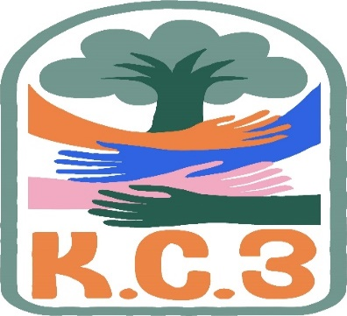
King County Community Collaborative- KC3
Voices of Change and Empowerment
January 25th,2022 5:30– 7:30 pm
Virtual Meeting
VISION
Together families, youth, systems, and communities will address the barriers to and equity for all individuals, including Black, Indigenous, Persons of Color, lesbian, gay, bisexual, transsexual, two-spirited, queer, questioning, intersex, and/or asexual individuals. We support opportunities to improve the resilience and recovery of children, youth, and families with physical, emotional or behavioral health challenges.
MISSION
Our mission is to strengthen and sustain community resources that effectively address the individual and their systems. We are allies in the support of equity for all; including Black, Indigenous, Persons of Color, lesbian, gay, bisexual, transsexual, two-spirited, queer, questioning, intersex, and/or asexual communities on multiple levels. We look to support our communities around physical health, behavioral health, social connection, practical aspects and spirituality when applicable. We extend goodwill to all individuals as we work together in a safe and supportive environment to together build a stronger King County.

As a Council of leaders of family and youth-led organizations serving families and youth with emotional and behavioral health challenges, we will represent the voices of King County families and youth at State and County policy and program decision making bodies.

Agenda
Welcome & Introductions: Facilitator: Cole, Notes: Le Chez
Invite you to share your name and your role in the chat
If this is your first time and would like to share who you are please feel free too.
Intro new activity to our meeting there will be prizes!
Evaluation link https://www.surveymonkey.com/r/KC301262022
Community Input and Concerns:
HB:1865 Pattie M. & LaTonya
KC3 Supporting community healing / workforce Cole, Chelsea, Candace

Update:
KC-SPARKS
WSCC
Workgroup recruitment update
Workgroups:
Workplan workgroup
Youth Engagement

Sharing Announcements, Updates:
KC3 engagement Activity Time
Thank you for attending. Be safe, stay well. Next meeting Feb 22,2022
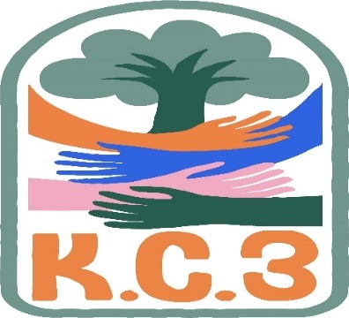

King County Community Collaborative- KC3
Voices of Change and Empowerment
Comfort Agreement

Stay on task
No side conversations
Cell phones on silent
Safe learning environment
Be willing to give and receive feedback
Leave your agency hat at the door. Bring your experience expertise and commitment.
Remember we all bring the best intentions to our work
Value everyone’s opinion
Ask questions and check out your assumptions and thinking
Listen carefully
Let your voice be heard
Provide space to hear about immediate concerns
Seek common ground and action
Identify areas of continued debate and defer to another day
If dissenting, offer an alternative
Be clear about discussion versus decision-making
Start meetings on time
Observe time frames

King County’s Family and Youth Council FYC Regional FYSPRT

Safety Plan

If anyone during the meeting begins to feel uneasy or frustrated:
- First take a break, Leave the room if needed, and use the coping skills that are familiar to you
- Second reach out to support people in the room
- Third, Tri-leads will offer support to anyone who signals distress-emotionally or otherwise.
- Lastly, reach out to those in the room who have background n de-escalation (all Tri-leads, Convener, Mental Health Provider
FYC Tri-leads will identify exits for members and attends will know how to safely exit the room if needed
FYC members and attendees agree to be present, aware and know who in the room (i.e. Tri-leads, Metal Health Providers individuals trained in de-escalation).
FYC Tri-leads and welcome committee will offer breaks to the group and individuals if conversations get heated or someone is signaling discomfort or distressed,
If Aggressive behavior is present and you have no experience with de-escalation techniques, please find an exit and leave the room.
- IF you do have de-escalation experience you may provide support if you feel comfortable with this. If you feel unsafe or prefer to not engage with an aggressive individual, please find safe space and/or exit the room.

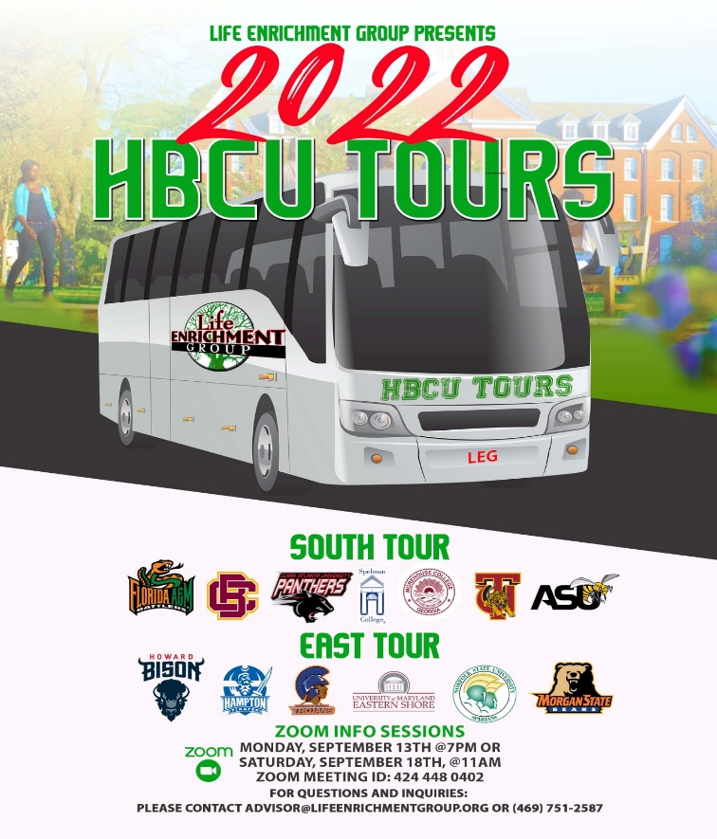

Attached you will see our flyer for our Black College Tour as well as The Scholars Project. Registration is still open for both and below are the application https://form.jotform.com/211247274215146

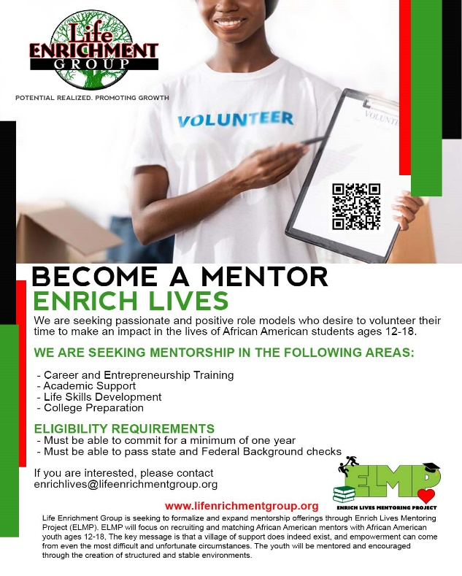

Sharing Resources and information for Families
Partner organization's events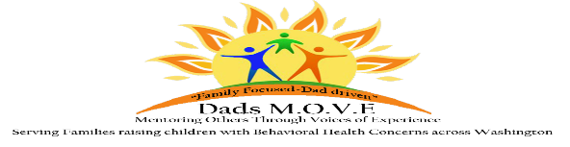

Washington state Fathers network; We do our work by connecting men with each other and with resources and information, by training men to tell their story and advocate for change, and by working to promote inclusion.
We firmly believe that:
Those who identify as male are superb resources for each other
Those who identify as male have needs of their own when they have a child in their life who has a disability or special health care need
The voice and perspective of those who identify as male need to be heard
As an organization and as individuals we need to advocate for equitable access to the community for those with disabilities or special health care needs, and their families
November 2, 2021: Maintaining Relationship Resilience While Parenting a Child with Special Need

December 7, 2021: Guardianships and Trusts

For more information click here

PAVE pave+wapave.org@ccsend.com

NAMI
https://www.nami.org/Get-Involved/Awareness-Events/Suicide-Prevention-Awareness-Month

