King County Community Collaborative- KC3
Voices of Change and Empowerment
October 26,2021 5:30– 7:30 pm
Virtual Meeting

VISION
Together families, youth, systems, and communities will address the barriers to and equity for all individuals, including Black, Indigenous, Persons of Color, lesbian, gay, bisexual, transsexual, two-spirited, queer, questioning, intersex, and/or asexual individuals. We support opportunities to improve the resilience and recovery of children, youth, and families with physical, emotional or behavioral health challenges.

MISSION
Our mission is to strengthen and sustain community resources that effectively address the individual and their systems. We are allies in the support of equity for all; including Black, Indigenous, Persons of Color, lesbian, gay, bisexual, transsexual, two-spirited, queer, questioning, intersex, and/or asexual communities on multiple levels. We look to support our communities around physical health, behavioral health, social connection, practical aspects and spirituality when applicable. We extend goodwill to all individuals as we work together in a safe and supportive environment to together build a stronger King County.

As a Council of leaders of family and youth-led organizations serving families and youth with emotional and behavioral health challenges, we will represent the voices of King County families and youth at State and County policy and program decision making bodies.

Agenda
Welcome & Introductions: Facilitator: Selina
Invite you to share your name and your role in the chat
If this is your first time and would like to share who you are please feel free too.
Community Input and Concerns:
WSCC
Presentation:
SB-SBRIT- School Base Intervention- Margaret Soukup, School-Based SBIRT Manager
Life Enrichment Group- LEG; Monica Mathews, Tajiana M. Ellis

Update:
KC-SPARKS
WSCC
Workgroups:
Workplan workgroup
Youth Engagement

Sharing Announcements, Updates:
Thank you for attending. Be safe, stay well!

King County’s Family and Youth Council Comfort Agreement

Stay on task
No side conversations
Cell phones on silent
Safe learning environment
Be willing to give and receive feedback
Leave your agency hat at the door. Bring your experience expertise and commitment.
Remember we all bring the best intentions to our work
Value everyone’s opinion
Ask questions and check out your assumptions and thinking
Listen carefully
Let your voice be heard
Provide space to hear about immediate concerns
Seek common ground and action
Identify areas of continued debate and defer to another day
If dissenting, offer an alternative
Be clear about discussion versus decision-making
Start meetings on time
Observe time frames

King County’s Family and Youth Council FYC Regional FYSPRT

Safety Plan

If anyone during the meeting begins to feel uneasy or frustrated:
- First take a break, Leave the room if needed, and use the coping skills that are familiar to you
- Second reach out to support people in the room
- Third, Tri-leads will offer support to anyone who signals distress-emotionally or otherwise.
- Lastly, reach out to those in the room who have background n de-escalation (all Tri-leads, Convener, Mental Health Provider
FYC Tri-leads will identify exits for members and attends will know how to safely exit the room if needed
FYC members and attendees agree to be present, aware and know who in the room (i.e. Tri-leads, Metal Health Providers individuals trained in de-escalation).
FYC Tri-leads and welcome committee will offer breaks to the group and individuals if conversations get heated or someone is signaling discomfort or distressed,
If Aggressive behavior is present and you have no experience with de-escalation techniques, please find an exit and leave the room.
- IF you do have de-escalation experience you may provide support if you feel comfortable with this. If you feel unsafe or prefer to not engage with an aggressive individual, please find safe space and/or exit the room.

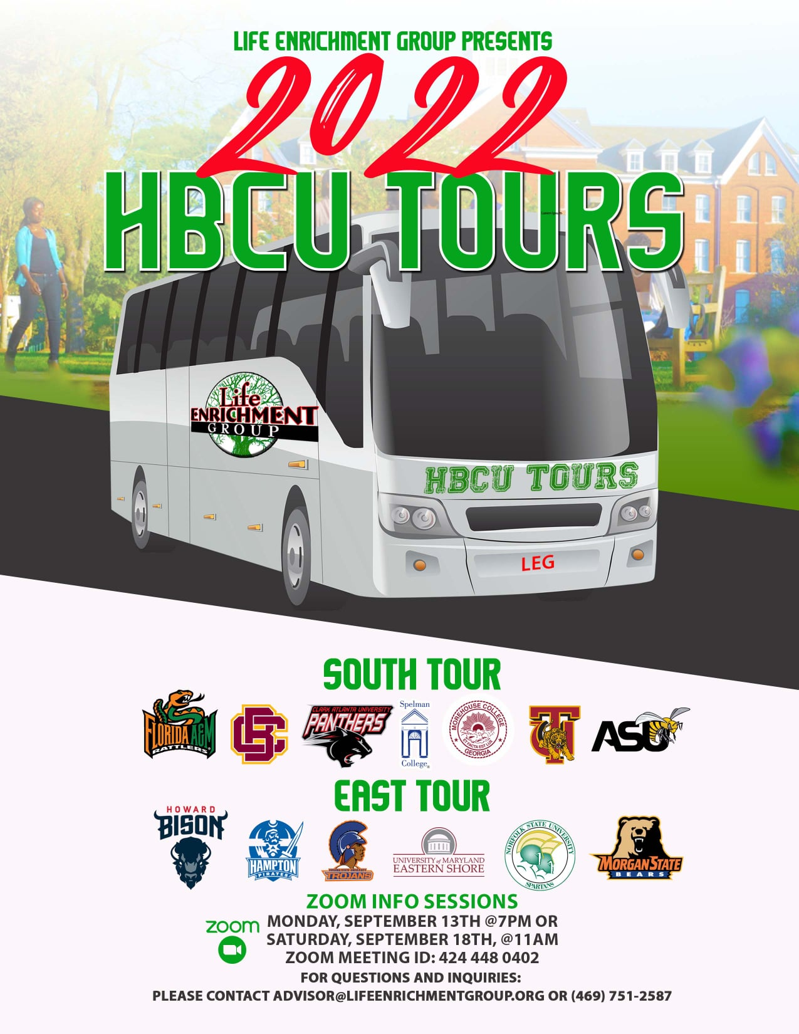
Attached you will see our flyer for our Black College Tour as well as The Scholars Project. Registration is still open for both and below are the application https://form.jotform.com/211247274215146

Youth Opportunity: Community Health Professions Academy (University of Washington School of Dentistry High School Program) What an incredible FREE opportunity for kids 8th through 12th grades! Please share widely.
Sharing Resources and information for Families
Paul Brown and Dads MOVE pbrown+dadsmove.org@ccsend.com
PAVE pave+wapave.org@ccsend.com

NAMI
https://www.nami.org/Get-Involved/Awareness-Events/Suicide-Prevention-Awareness-Month

