Notes
King County Community Collaborative- KC3
Voices of Change and Empowerment
October 26,2021 5:30– 7:30 pm
Virtual Meeting

VISION
Together families, youth, systems, and communities will address the barriers to and equity for all individuals, including Black, Indigenous, Persons of Color, lesbian, gay, bisexual, transsexual, two-spirited, queer, questioning, intersex, and/or asexual individuals. We support opportunities to improve the resilience and recovery of children, youth, and families with physical, emotional or behavioral health challenges.

MISSION
Our mission is to strengthen and sustain community resources that effectively address the individual and their systems. We are allies in the support of equity for all; including Black, Indigenous, Persons of Color, lesbian, gay, bisexual, transsexual, two-spirited, queer, questioning, intersex, and/or asexual communities on multiple levels. We look to support our communities around physical health, behavioral health, social connection, practical aspects and spirituality when applicable. We extend goodwill to all individuals as we work together in a safe and supportive environment to together build a stronger King County.

As a Council of leaders of family and youth-led organizations serving families and youth with emotional and behavioral health challenges, we will represent the voices of King County families and youth at State and County policy and program decision making bodies.

Agenda
Welcome & Introductions: Facilitator: Selina
Invite you to share your name and your role in the chat
If this is your first time and would like to share who you are please feel free too.
Community Input and Concerns:
WSCC -
Presentation:
SB-SBRIT- School Base Intervention- Margaret Soukup, School-Based SBIRT Manager

Wonderful informative presentation by Margaret. Please see powerpoint. Margaret is happy to help answer questions if the material will be shared with the community.

Update:
KC-SPARKS: New leadership Students Providing And Receiving Knowledge
If you are unfamiliar with SPARK, they are an organization that is leading the youth peer movement in Washington State. They primarily provide youth peer counselor trainings and development opportunities, but they also advocate for recovery in the process. Although they are originally from the Tri-Cities area on the east side of the state, they are now expanding to other counties throughout Washington with King County being one of their priorities. Through this partnership, we hope to provide local youth with a plethora of options to get involved in their communities and use their voice. We are currently forming a development team to establish SPARK in King County so there are more updates to come. Please reach out if you would like to collaborate on this important project.
WSCC -New Substance Use Disorder (SUD) Family Support training. 16-hour training for parents, caregivers, and/or family members who are interested in learning how to support their loved ones with substance use disorders. This is also open to system partners who have lived experience or want to know the content the families they serve are learning.
- Science of SUD
- Skills
- Tools
- In partnership with EnRoute

Workgroups:
Workplan workgroup: We are looking for members to join this workgroup. Currently our tri leads are reviewing this document, but welcome new ideas and representation from the community
Youth Engagement: This group meets the second Tuesday of the month from 12-1 via zoom: https://washington.zoom.us/j/92624481542
This group focuses discussions on how we can build community and enhance youth voice in the behavioral health system. We support projects and build connections to enhance our work through collaboration. Currently this group is comprised of system partners and a few peers, but we hope to increase participation with youth and young adults.

Sharing Announcements, Updates:
If you would like to contact any of the tri-leads (Youth: Gabriel Hamilton, LeChez Bowser, and myself; Family: Chelsea Berg, Jennifer Miller, Selina Sweet; System: Candace Hunsucker) or our amazing convener, LaTonya Rogers, one option to do so is by emailing the recently created email address: kingcountyfysprt@gmail.com. All the tri-leads and LaTonya will have access to this email so that we can operate out of the same inbox, utilize a shared calendar, and use services such as Google Drive. We believe that this will help us to be both more efficient and equitable. The email address is active but please bear with us as we adapt to it over time.
Thank you for attending. Be safe, stay well!

King County’s Family and Youth Council Comfort Agreement

Stay on task
No side conversations
Cell phones on silent
Safe learning environment
Be willing to give and receive feedback
Leave your agency hat at the door. Bring your experience expertise and commitment.
Remember we all bring the best intentions to our work
Value everyone’s opinion
Ask questions and check out your assumptions and thinking
Listen carefully
Let your voice be heard

Provide space to hear about immediate concerns
Seek common ground and action
Identify areas of continued debate and defer to another day
If dissenting, offer an alternative
Be clear about discussion versus decision-making
Start meetings on time
Observe time frames

King County’s Family and Youth Council FYC Regional FYSPRT

Safety Plan

If anyone during the meeting begins to feel uneasy or frustrated:
- First take a break, Leave the room if needed, and use the coping skills that are familiar to you
- Second reach out to support people in the room
- Third, Tri-leads will offer support to anyone who signals distress-emotionally or otherwise.
- Lastly, reach out to those in the room who have background n de-escalation (all Tri-leads, Convener, Mental Health Provider
FYC Tri-leads will identify exits for members and attends will know how to safely exit the room if needed
FYC members and attendees agree to be present, aware and know who in the room (i.e. Tri-leads, Metal Health Providers individuals trained in de-escalation).
FYC Tri-leads and welcome committee will offer breaks to the group and individuals if conversations get heated or someone is signaling discomfort or distressed,
If Aggressive behavior is present and you have no experience with de-escalation techniques, please find an exit and leave the room.
- IF you do have de-escalation experience you may provide support if you feel comfortable with this. If you feel unsafe or prefer to not engage with an aggressive individual, please find safe space and/or exit the room.

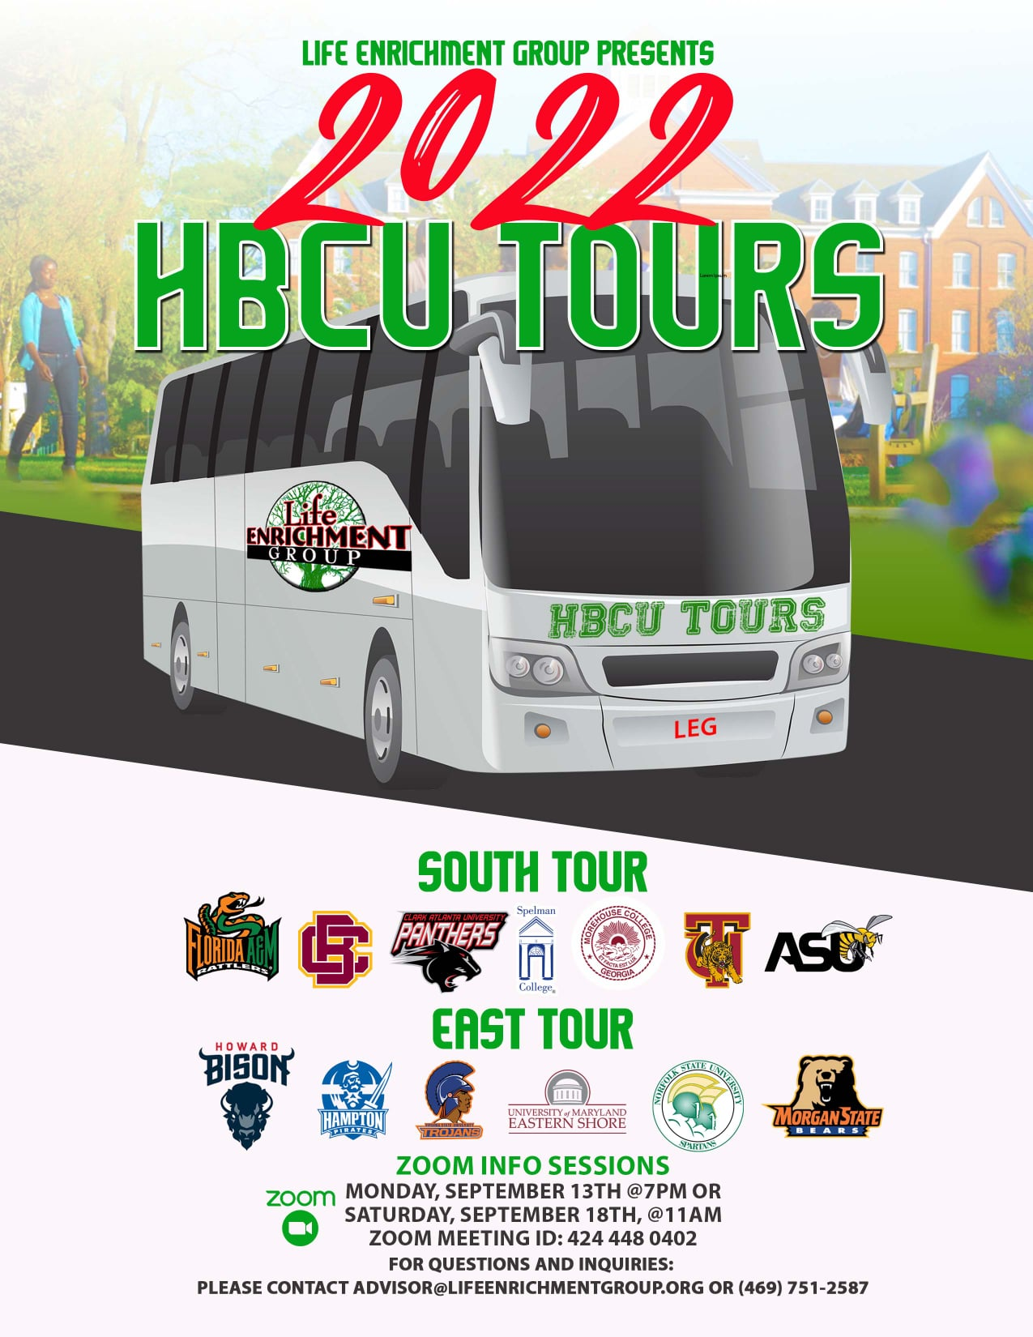
Attached you will see our flyer for our Black College Tour as well as The Scholars Project. Registration is still open for both and below are the application https://form.jotform.com/211247274215146

Youth Opportunity: Community Health Professions Academy (University of Washington School of Dentistry High School Program) What an incredible FREE opportunity for kids 8th through 12th grades! Please share widely.
Sharing Resources and information for Families
Paul Brown and Dads MOVE pbrown+dadsmove.org@ccsend.com
PAVE pave+wapave.org@ccsend.com

NAMI
https://www.nami.org/Get-Involved/Awareness-Events/Suicide-Prevention-Awareness-Month

