Introduction
King County is striving to build a workplace where you can thrive – where you are supported to learn, grow, innovate, and do your best work for our community. To this end, we have created tools and resources to help you take charge of your career growth. An Individual Development Plan (IDP) is a tool to help you clarify your career goals and create an action plan to help you reach them – be it advancement in your current field, a complete change of career, or to enhance your knowledge and skills for your current position. Below are recommended steps and links to resources to help you create a Road Map to Your Future.
Date: |  | Current Job: |  | Department/Division:

- Identify Your Career Goal/s
The first step when creating a road map is to have a clear destination in mind. So, take some time to research, explore and identify one or more career options you want to pursue within the next 1-2 years. At www.kingcounty.gov/CSS under “Career Exploration and Job Search,” there are links to external resources to help you take stock of what interests you, what skills you enjoy using, and enable you to explore career options. You will also find a link about using transferable skills to shift your career, links to King County’s job classification descriptions along with what these classifications pay. You may want to look at job postings and network and talk with those in the career field you are pursuing to determine whether it is a direction you want to pursue. Use the space below to list your career goal/s.

Career Goal/s:

- Strengths and Growth Areas
Based on your career goal/s, and what you learned from your self-assessment and research, use the table below to create a list of strengths you would bring, which may include experience, competencies, institutional or other knowledge, and transferable skills. You might also seek input on your strengths from others who know you such as your friends, family, supervisor, co-workers, mentor, and customers. Also use the table below to Identify areas you want to obtain, or develop to help you reach your career goal/s.

STRENGTHS  What I Will Bring to My Career Goal/s | GROWTH AREAS TO DEVELOP  Experience, Competencies, Knowledge, or Skills I Need to Obtain or Enhance
- Action Plan: Development Activities (70/20/10 Learning Model)
Pulling from the “Growth Areas to Develop” that you listed above, use the table below to identify several activities you can pursue to help you develop in those areas. Remember to include target dates to help keep you moving forward towards your career goal/s. Keep your activities manageable, so you don’t get overwhelmed. You may find it helpful to use an Asterix (*, **, ***) to prioritize the order you want to work on these development activities. It is strongly recommended that you seek input and suggestions from others who have experience or expertise in the area you want to develop. Keep in mind that small steps can have big results so remember to celebrate completion of development activities and create new ones to keep you moving forward. Using the 70/20/10 Learning Model, examples of development activities could include:

- Experience based (70% of your activities): i.e., new duties or projects; volunteer work in the community, with a non-profit organization or even a private sector company; presenting to senior leadership; participating on a project team, special committee or task force; special duty assignments  - Learning with others (20% of your activities): i.e., coaching, mentoring, job shadowing, guidance from supervisor, peer to peer learning, communities of practice, networking, professional associations, informational interviews  - Education and training (10% of your activities): i.e., e-learning, video or computer-based training, courses/seminars, formal education, reading materials, conferences | 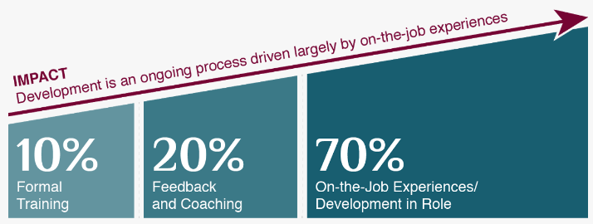

Experience / Competency / Knowledge / Skill to Develop | Development Activities with Target Dates
 | Experience (70%) | Learning with Others (20%) | Education or Training (10%)

- Seek Organizational Alignment
By taking the time to seek alignment and center the purpose of your development activities around furthering (A) King County’s “True North” and values; (B) the County’s Equity and Social Justice (ESJ) vision and; (C) your ability to better serve your customers, your organization, the County and/or the community we serve, you provide a more compelling story for your supervisor when seeking their support for your development activities. In fact, explaining alignment is especially important if you ask your organization to pay for training. You may want to have an alignment discussion with your department’s Equity, Inclusion and Belonging Manager, Career Support Services staff, or others. Use the space below to explain alignment.

SPECIAL NOTE: If you meet eligibility requirements for the Professional Development Scholarship Program, this alignment will be asked for as part of the scholarship application process.

- (Optional) Supervisor Support
INDIVIDUAL: If you want to enlist your supervisor for support towards your achieving your career goal/s, identify specific ways in which they could provide that support and list them below. Then begin a conversation with your supervisor to get feedback on your IDP, discuss support options and document any agreements made. If there are possible workplace obstacles that could affect your ability to take part in any of your development activities, discuss them with your supervisor to see if there may be a way to address them.
SUPERVISOR: Provide helpful suggestions on their IDP, offer encouragement and celebrate progress and success along the way. Work collaboratively with your employee to find ways in which you can provide support or address obstacles, which may include working with your leadership and HR to address possible organizational, operational, business, or HR related barriers.

Individual’s Specific Request of Supervisor | What Supervisor Agrees to Do | Timeline/Duration

- (Optional) Mentor or Other Support
INDIVIDUAL: If you want to enlist a mentor or other person for feedback on your IDP, or for guidance and support towards your achieving your career goal/s, name specific ways in which they could provide guidance and support and list them below. Then begin a conversation with them to gather their feedback, discuss guidance and support options and document any agreements made.
MENTOR/OTHER SUPPORT PERSON: Provide helpful suggestions on their IDP, offer encouragement and celebrate progress and success along the way. Work collaboratively with the individual to find ways in which you can provide guidance, support or identify possible solutions to address obstacles.

Individual’s Specific Request of Mentor/Other | What They Agree to Do | Timeline/Duration

- (Optional) Check-Ins
INITIAL MEETING DATE:  With Whom:  Discuss and obtain feedback on IDP, career goals, development activities, support desired and any agreements | CHECK IN DATE:  With Whom:  Discuss development activities, status, changes to IDP, celebrate progress and accomplishments, update agreements | CHECK IN DATE:  With Whom:  Discuss development activities, status, changes to IDP, celebrate progress and accomplishments, update agreements
Comments or Agreements | Comments or Agreements | Comments or Agreements

