

**Training Materials: Engagement Action Planning**

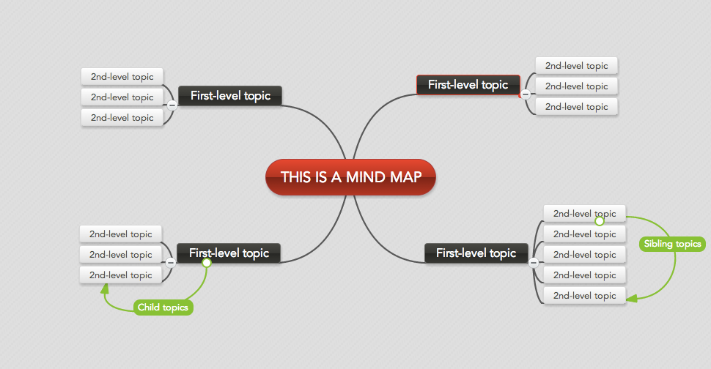

**Mind Maps**

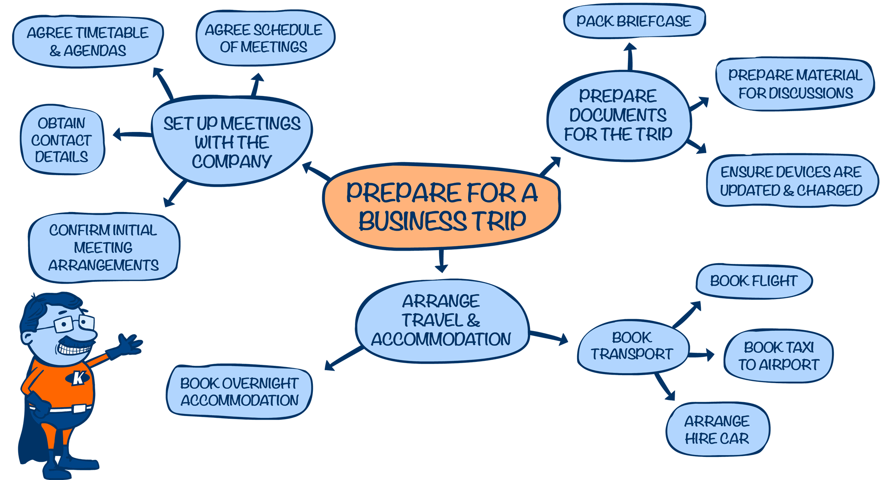

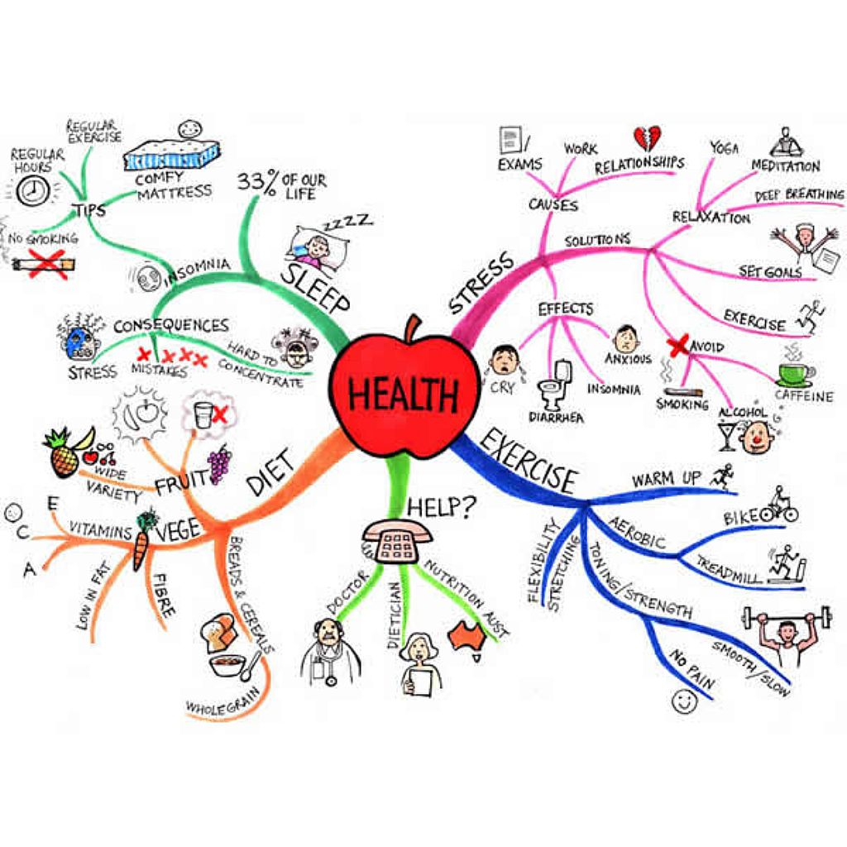

**Engagement Drivers**

The things that motivate people and drive the actions that translate to saying positive things about the organization, staying with the organization and striving to do the very best.

* **Connection to Mission** refers to when employees understand the mission and purpose of the organization, and how their work contributes to the mission.
* **Trust in senior leadership** means that employees are confident that the organization’s leadership is taking the organization in a good direction, communicates openly and honestly, and models the behavior they expect to see among employees.
* **Relationship with supervisor** – the supervisor relationship is pivotal in employee engagement. Employees are most engaged with their supervisor can provide direction and feedback, cares about them and helps them succeed and grow in their career. Supervisors also set the tone for a workgroup by how they manage conflict and hold people accountable.
* **Peer culture** – we all know how a great team can keep us going. Peer culture drives engagement when the group is open to new ideas, cooperate, and treat each other with respect.
* **Personal influence** refers to our ability to have a say in how we do our work, authority and empowerment to get our work done, and satisfaction with how we manage our workload.
* **Growth and development** – employees are engaged in workplaces where they have opportunities to advance in their career and can gain skills and knowledge.
* **Recognition** is important because it shows that someone is paying attention to your work and signals that the work matters.
* **Work environment** includes the factors that enable employees to get their work done – safety, respect, and access to tools, resources & information.

**How We Include: The Dimensions of Inclusion**

|  |  |
| --- | --- |
| **Dimension of inclusion[1]** | **Survey questions[2]** |
| Autonomy – Am I given choices and control? | * I have the authority I need to do my job effectively * I have a say in how I complete everyday job duties * I feel encouraged to share new ideas to improve the way we work |
| Belonging – Do I belong? | * I feel trusted to do my job well * My supervisor gives me regular, constructive feedback on my performance * There is a spirit of team work and cooperation among the members of my work unit |
| Certainty – Am I in the loop? | * I am clear about what I am expected to achieve in my job * I receive the information I need to do my job well |
| Fairness – Do I get the credit and opportunities that others do? | * I have equal access to employee development opportunities * I have equal access to staff advancement opportunities * I am satisfied with the recognition I receive for doing a good job. |
| Standing – Am I respected and valued? | * I am treated with respect in my workplace * I feel safe in my workplace |

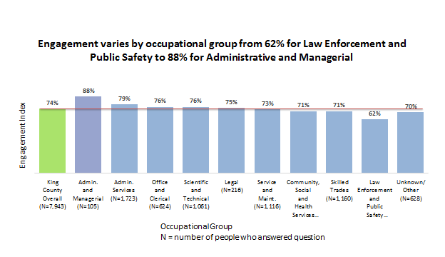 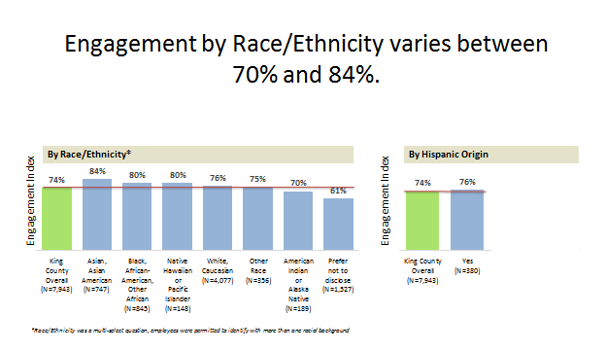 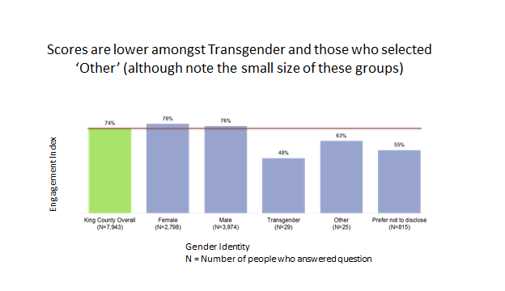

***Demographic groups which differ from King County overall on countywide key drivers:***

**Q41 Use goals and measures developed by my work unit to guide performance**

Countywide average = 57%

* Above:
  + Age 18-25 (71%)
  + Less Than 1 Year of Tenure (75%)
* Below:
  + Veteran (53%)

**Q50 Treated with respect in my workplace**

Countywide average = 56%

* Above:
  + 0-6 Months Tenure (94%)
  + Age 66 or older (84%)
* Below:
  + Transgender (52%)

**Q42 Opportunities to achieve career goals**

Countywide average = 56%

* Above:
  + 0-6 Months Tenure (85%)
  + Less Than High School Diploma (71%)
* Below:
  + 20+ Years Tenure (47%)

**Key Driver Analysis: Q57 “I have the support to apply equity and social justice to my work”**

* + Countywide key driver question
  + Also a key driver for 4/9 departments (DCHS, DES, DPH, DNRP)

|  |  |  |  |
| --- | --- | --- | --- |
| **Team** | **Top Key Driver Questions That Impact Engagement** | | |
| **1st** | **2nd** | **3rd** |
| **King County Overall** | q41 I use goals and measures developed by my work unit to help guide my performance and work priorities | q50 I am treated with respect in my workplace | q57 I have the support to apply equity and social justice to my work |
| **Women** | q50 I am treated with respect in my workplace | q55 I am supported in balancing my work and home life | q51 I am satisfied with King County's programs to help me manage my health |
| **Men** | q41 I use goals and measures developed by my work unit to help guide my performance and work priorities | q39 I am satisfied with the level of challenge in my work | q1 My departments/agency's goals give guidance to my work |
| **American Indian or Alaska Native** | q55 I am supported in balancing my work and home life | q52 I feel safe in my workplace | q57 I have the support to apply equity and social justice to my work |
| **Asian, Asian American** | q41 I use goals and measures developed by my work unit to help guide my performance and work priorities | q49 I receive the information I need to do my job well | q57 I have the support to apply equity and social justice to my work |
| **Black, African-American, other African** | q50 I am treated with respect in my workplace | q41 I use goals and measures developed by my work unit to help guide my performance and work priorities | q57 I have the support to apply equity and social justice to my work |
| **Native Hawaiian or Pacific Islander** | q43 I understand how I can advance in my career at King County | q42 I am satisfied with the opportunities available to achieve my career goals at King County | q44 In the last year, I have had opportunities to learn and grow professionally |
| **White, Caucasian** | q50 I am treated with respect in my workplace | q41 I use goals and measures developed by my work unit to help guide my performance and work priorities | q57 I have the support to apply equity and social justice to my work |
| **Other Race** | q50 I am treated with respect in my workplace | q49 I receive the information I need to do my job well | q57 I have the support to apply equity and social justice to my work |

**Your Reflection on 2016’s Action Plan**

* Assess your 2016 action plan (too big, small, hard, easy?)
* Who owned it? Who contributed to it?
* Did you see results based on the 2016 survey results?
* Do you have other ways of measuring results or impact?
* What did you learn (about your group, yourself, about what is possible)

**What is your biggest concern or challenge going into 2017 action planning?**

**What ideas have you heard that might help engage your group and come up with an impactful, inclusive action plan?**

**Employee Survey Action Plan Tracking Form (to be completed in Sharepoint)**

**Team:**

Point Person

Team Members

**Place in Organization:**

Department

Division

Section/Workgroup

**Workgroup discussion notes (Optional):**

**Focus:**

One Thing:

Engagement Driver

Equity and Inclusion Dimension(s)

**Action Plan:**

|  |  |  |  |
| --- | --- | --- | --- |
|  | Point Person | Action Due Date | Action Completed |
| Action 1 |  |  |  |
| Action 2 |  |  |  |

**Target Improvements:**

|  |  |  |  |  |  |
| --- | --- | --- | --- | --- | --- |
|  |  | Current Value | Target Value | When to measure | Plan to measure |
| Example | I use goal and measures developed by my work unit to help guide my performance and work priorities | 57% | 75% | Mar 31  June 30 | We will ask this question on a paper survey at team meetings. |
| Specific Survey Question(s) | 1. |  |  |  |  |
|  | 2. |  |  |  |  |
| Other | Example: Safety Incidents | # in the last 12 months | 50% reduction | 12 months from now | Monitor safety incidents monthly or quarterly. |
|  | Promotions |  |  |  |  |
|  | Stretch Assignments |  |  |  |  |
|  | Development Plans |  |  |  |  |
|  |  |  |  |  |  |

**Employee Survey Action Plan Tracking Form (Example)**

**Team:**

Point Person: Bob

Team Members: Bob, Sue, Charlie, Ezekiel, Brittany

**Place in Organization:**

Department: KC Dept

Division: generic Division

Section/Workgroup: generic Workgroup

**Discussion notes:**

The team discussed survey results. They expressed concerns about senior leadership not communicating very well and not providing a strong vision. They also talked about opportunities for career growth and how challenging it is to make a career change because they have limited access to training (work hours aren’t flexible, it’s hard to get backfill if they go to trainings, etc.). Since many of these thing are outside their control, I am going to communicate their concerns to my division leadership. Our action plan will be about getting more focused on our own goals and measures for our work in 2017. The team was excited about setting goals for what they need to accomplish and plan to recognize each other for meeting goals. They also think that meeting concrete goals will help them build their resume for any future job opportunities.

**Focus:**

One Thing: Visually track goals, measures, and projects completed

Engagement Driver: Personal Influence

Equity and Inclusion Dimension(s): Belonging, Certainty

**Action Plan:**

|  |  |  |  |
| --- | --- | --- | --- |
|  | Point Person | Action Due Date | Action Completed |
| Action 1  Create board to track goals, measures and completion of projects | Sue | 2/15 |  |
| Action 2  Meet once a week at board to report out and record progress on goals, measures and completed projects | Bob | 6/30 |  |

**Target Improvements:**

|  |  |  |  |  |  |
| --- | --- | --- | --- | --- | --- |
|  |  | Current Value | Target Value | When? | Plan? |
| Specific Survey Question(s) | Q41 **I use goals and measures developed by my work unit to help guide my performance and work priorities** | 43% | 100% | Mar 30th  June 30th | Customer paper survey at team meetings |
|  | **Q I am satisfied with the recognition I receive for doing a good job** | 57% | 85% | Same | Same |
|  | **I am clear about what I am expected to achieve in my job** | 57 | 85% | Same | Same |
| Other | Example: Safety Incidents | # in the last 12 months | 50% reduction | 12 months from now | Monitor safety incidents monthly or quarterly. |
|  | Service (productivity & delivery): # of project milestones accomplished on time | 0% | 75% |  |  |

**Online Tool Kit –** [**www.kingcounty.gov/employees/employeesurvey**](http://www.kingcounty.gov/employees/employeesurvey)

* Training Slides
* Timeline
* Discussion Guide
* Engagement Driver Tool Kits
* Action Plan Tracker
* Liberating Structures

**C:\Program Files (x86)\Microsoft Office\MEDIA\CAGCAT10\j0088542.wmf**C:\Program Files (x86)\Microsoft Office\MEDIA\CAGCAT10\j0088542.wmf

# Action Planning Meeting

# Facilitation Training

Are you a supervisor or manager who will be leading a team Action Planning meeting? Are you looking for some tried and true facilitation techniques to insure your meeting is inclusive, engaging and interactive? Facilitators Ann McBroom, Doug Nathan and Jonathon Halperin will provide you with a meeting template and lots of interactive facilitation options to help you get the most out of your meeting. These facilitation techniques are transferable to other meeting settings!

January 25th 2017, 8:30 a.m. to 4 p.m.

Chinook Room 126

RSVP to Kathleen Nichols at Kathleen.nichols@kingcounty.gov



1. From the Neuroleadership Institute
2. 2016 Survey questions that may relate to dimensions of inclusion