Employee Survey Report
This document provides a short overview of the Employee Survey to help you interpret the report.
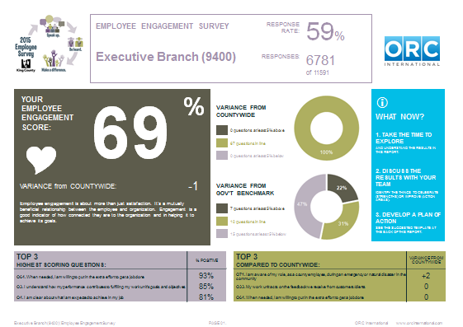
Cover Slide:

1. Response Rate

3. Variance donut charts
2. Employee engagement score

- Response rates: The response rate is the percentage of employees in the group that participated in the survey. We have a wide range of response rates, but overall they are solid and we feel good about the data. If you are concerned about your response rate being low (<40%), please email Shannon.Harris@kingcounty.gov to talk through ways of moving forward, despite the low response rate.
- Employee Engagement Score: The employee engagement score is a measure of how employees feel about working for King County. It is based on ORC’s framework “Say, Stay, Strive” and is the average of positive responses to questions 60-65 on page 15. We care about this because strong employee engagement is associated with better organizational performance.
- Variance donut charts: These charts provide a quick snapshot of how you compare to your parent (defined on page two of your report) and the county overall. The positive variance is five percentage points above the comparison unit, in-line is +/- five percentage points, and below is five percentage points below the comparison unit.

Slide 3: Key Questions to Focus On
There are two types of questions in the survey:

- Engagement Driver Questions: questions about things we can change about the work environment (Questions 1-59)

- Employee Engagement Questions: questions about employees’ attitude about working at King County in general (Questions 60-65)

This slide shows which Engagement Driver Questions have the strongest relationship to Employee Engagement Questions, based on statistical analysis. People who responded positively to these questions were more likely to respond positively to the Employee Engagement Questions, and those who responded negatively to these questions were more likely to respond negatively to the Employee Engagement Questions. By focusing on these questions in action planning, we can be more strategic about what we choose to work on because these are things that appear to matter to employees.

The questions on this slide are unique for departments and most divisions, and they are also unique for some sections. ORC performed the analysis for groups that were large enough for the analysis to be meaning.
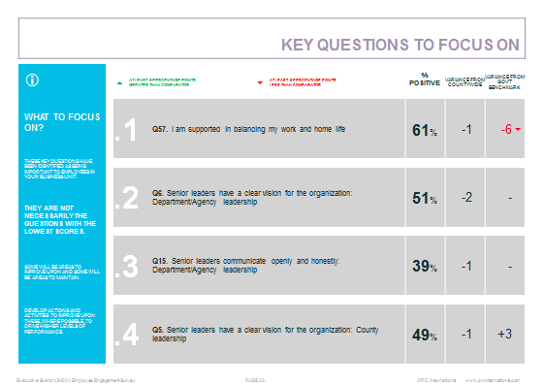
Slide 4: Headline Scores
This slide provides another way of looking at important questions, but instead of looking at what is most important to employees, this slide report what things were scored most positively, neutrally or negatively.

Highest Positive Scoring Questions are things to celebrate – and learn more about what you are doing well.

Highest Neutral Scoring Questions are places where the employees think things are inconsistent, or they are indicating they don’t have enough information or exposure to what is being asked about. These are areas where we want to dig deeper and learn more about employees experience – sometimes these scores can be shifted positively just by providing more information or making things more consistent.

Highest Negative Scoring Questions are places where there may be red flags – areas where an issue may need to be addressed more immediately. However, just because something is scored more negatively doesn’t mean it is important to employees, so ask about how much of a priority it is to your employees that these negatively scoring questions be addressed.

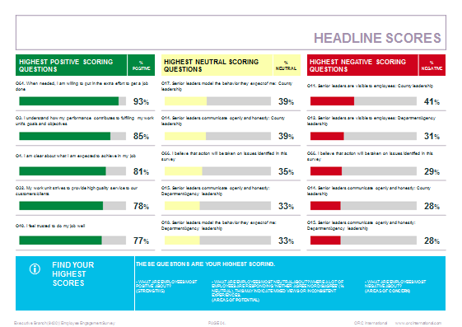

Slides 6-14: All Questions – Engagement Driver Questions

This set of slides shows the responses and the response scale for all questions in the survey. There are also variances reported here, as there were in the Key Questions to Focus on Slide.

The column with “variance from parent” shows how many percentage points of variation there are between your group and the next level up in the organization.

The column with “variance from countywide” shows how many percentage points of variation there are between your group and the rest of the county.

The column with “variance from gov’t benchmark” shows how many percentage points of variation there are between your group and the external government benchmark that ORC provides. This is an average of positive responses from public sector organizations around the world. If there is a “-“, that indicates the question was not comparable to the government benchmark question.

The grey bar at the bottom explains some of the symbols and coloring. The bar that goes from dark green to dark red shows the percentage of employees who responded in each response category. The dark green and darkest red bars have white font for better contrast.

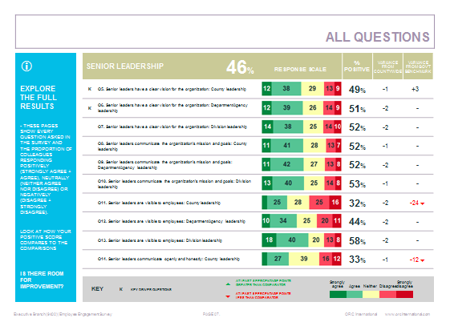

Slide 15: Employee Engagement Questions
These questions show employees attitudes about working at King County in general and make up our measure for employee engagement.
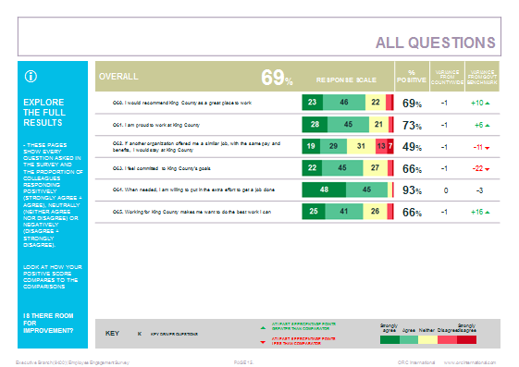

Slide 16: Taking Action
This slide shows the percentage of employees who believe action will be taken on the survey, versus those who are neutral or negative.
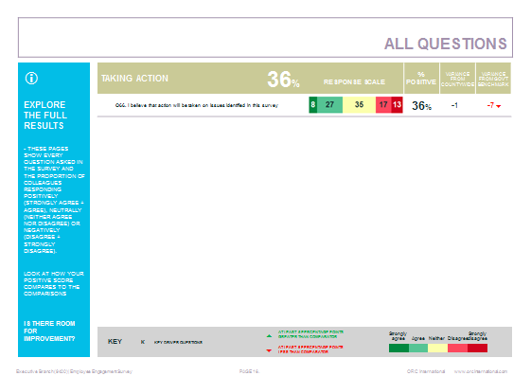

Slide 17: County Initiatives
This question asked about employees’ knowledge of their role in an emergency. It was asked by the Office of Emergency Management so they know where they should focus on educating employees about their role during an emergency or natural disaster.

Slide 18:
For some, these are where agency specific questions start. If your group didn’t have agency specific questions, then the slides continue with County Initiatives, which were asked to learn how we can better communicate with our employees and which initiatives require additional awareness-raising and education.

Taking Action slide: This slide emphasizes the response from employees about their confidence that we will take action. It is a call to action to respond to the survey results in a meaningful way.

Time to Take Action: This is a tool that outlines a process for creating an action plan to address the issues identified in the survey. If you have questions about this tool, contact Brooke Bascom at brooke.bascom@kingcounty.gov

Additional resources will be posted on the Employee Survey intranet site:
https://kc1.sharepoint.com/sites/ECP/empsurvey/Pages/default.aspx

